DATA-236 - Distributed Systems for Data Engineering

HOMEWORK 5

Vimalanandhan Sivanandham

017596436

**GitHub** - <https://github.com/Vimalanandhan/DATA-236---Distributed-Systems-for-Data-Engineering/tree/main/Assignments/Assignment%205>

**PART -1**

**AUTHORS API endpoints**

**1. GET /library/authors** - Get all authors.

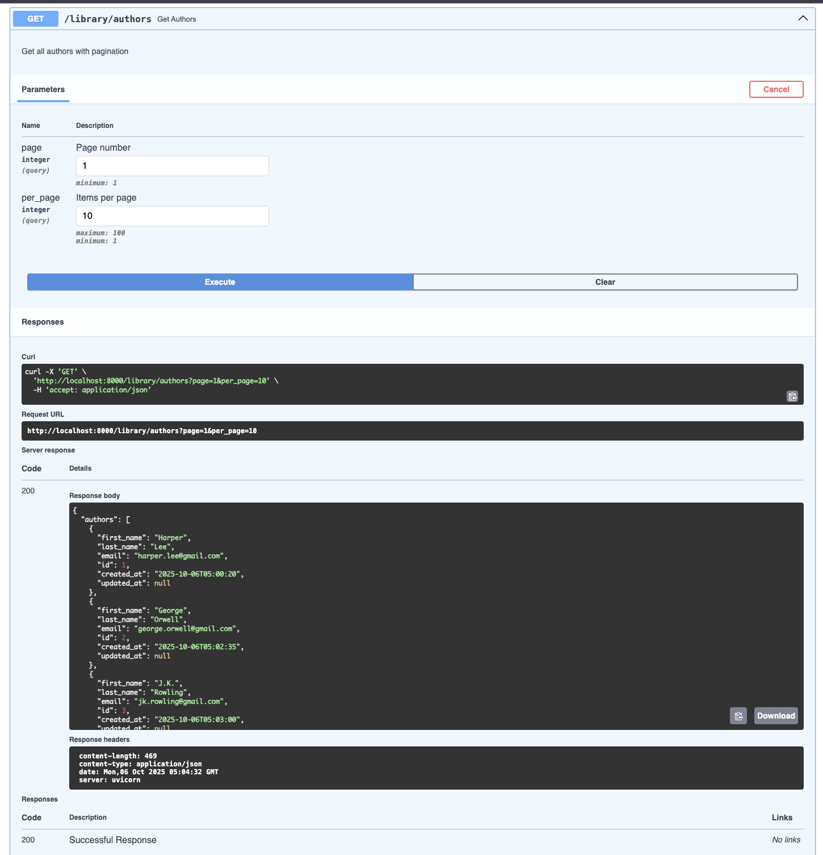

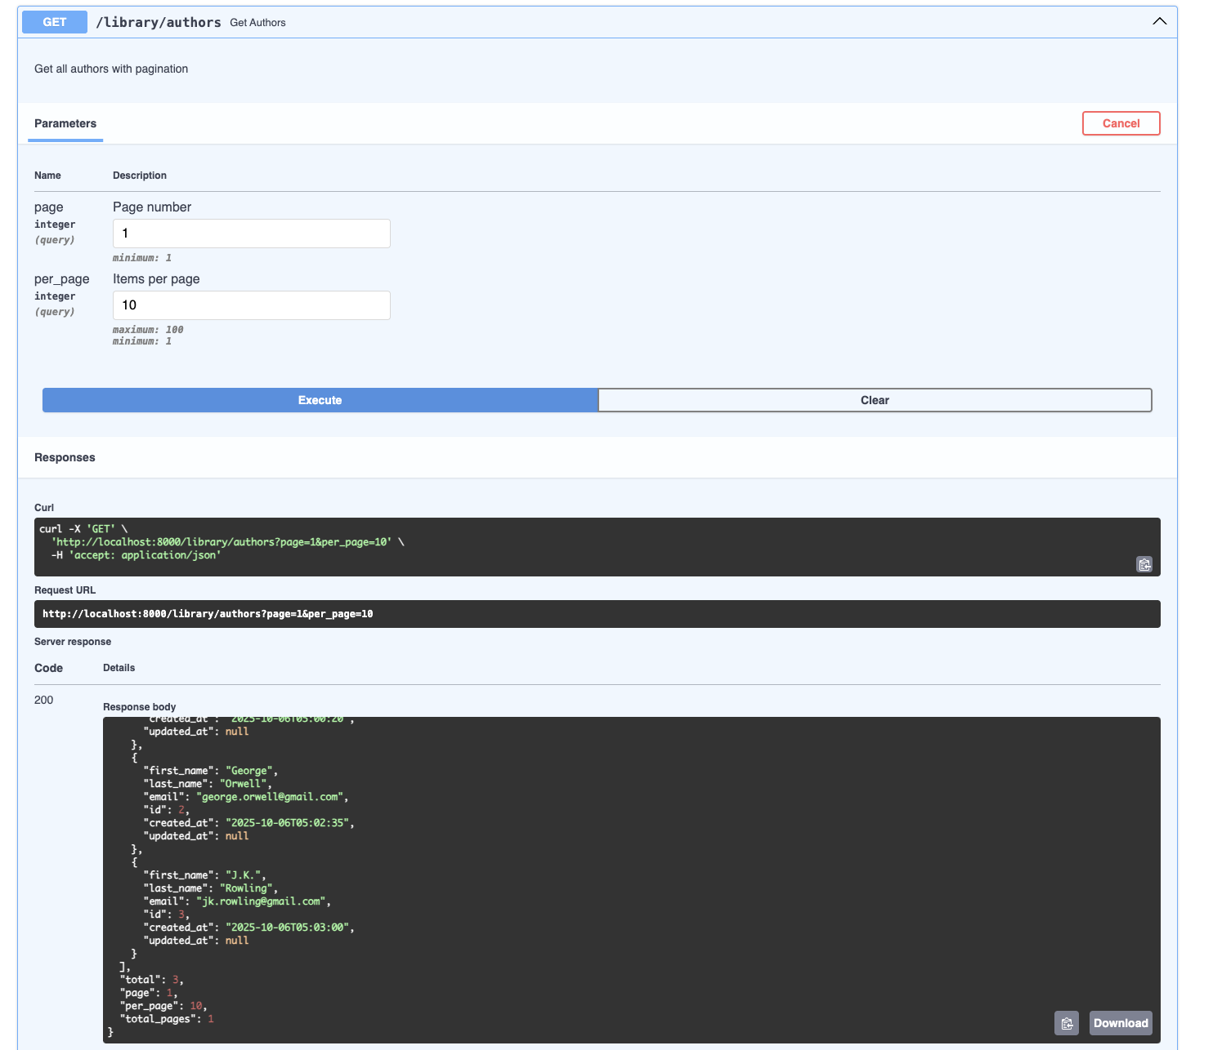

**SQL Screenshot:**

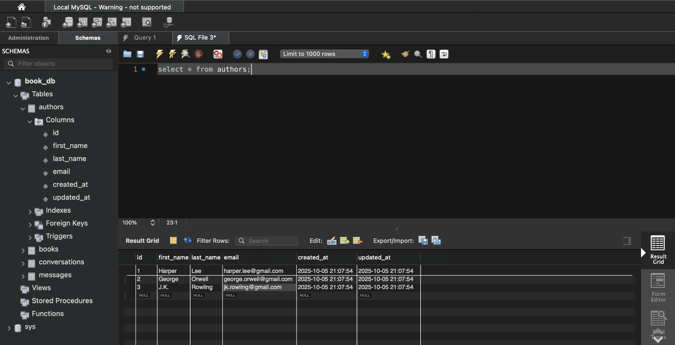

**2. POST /library/authors** - Create new author

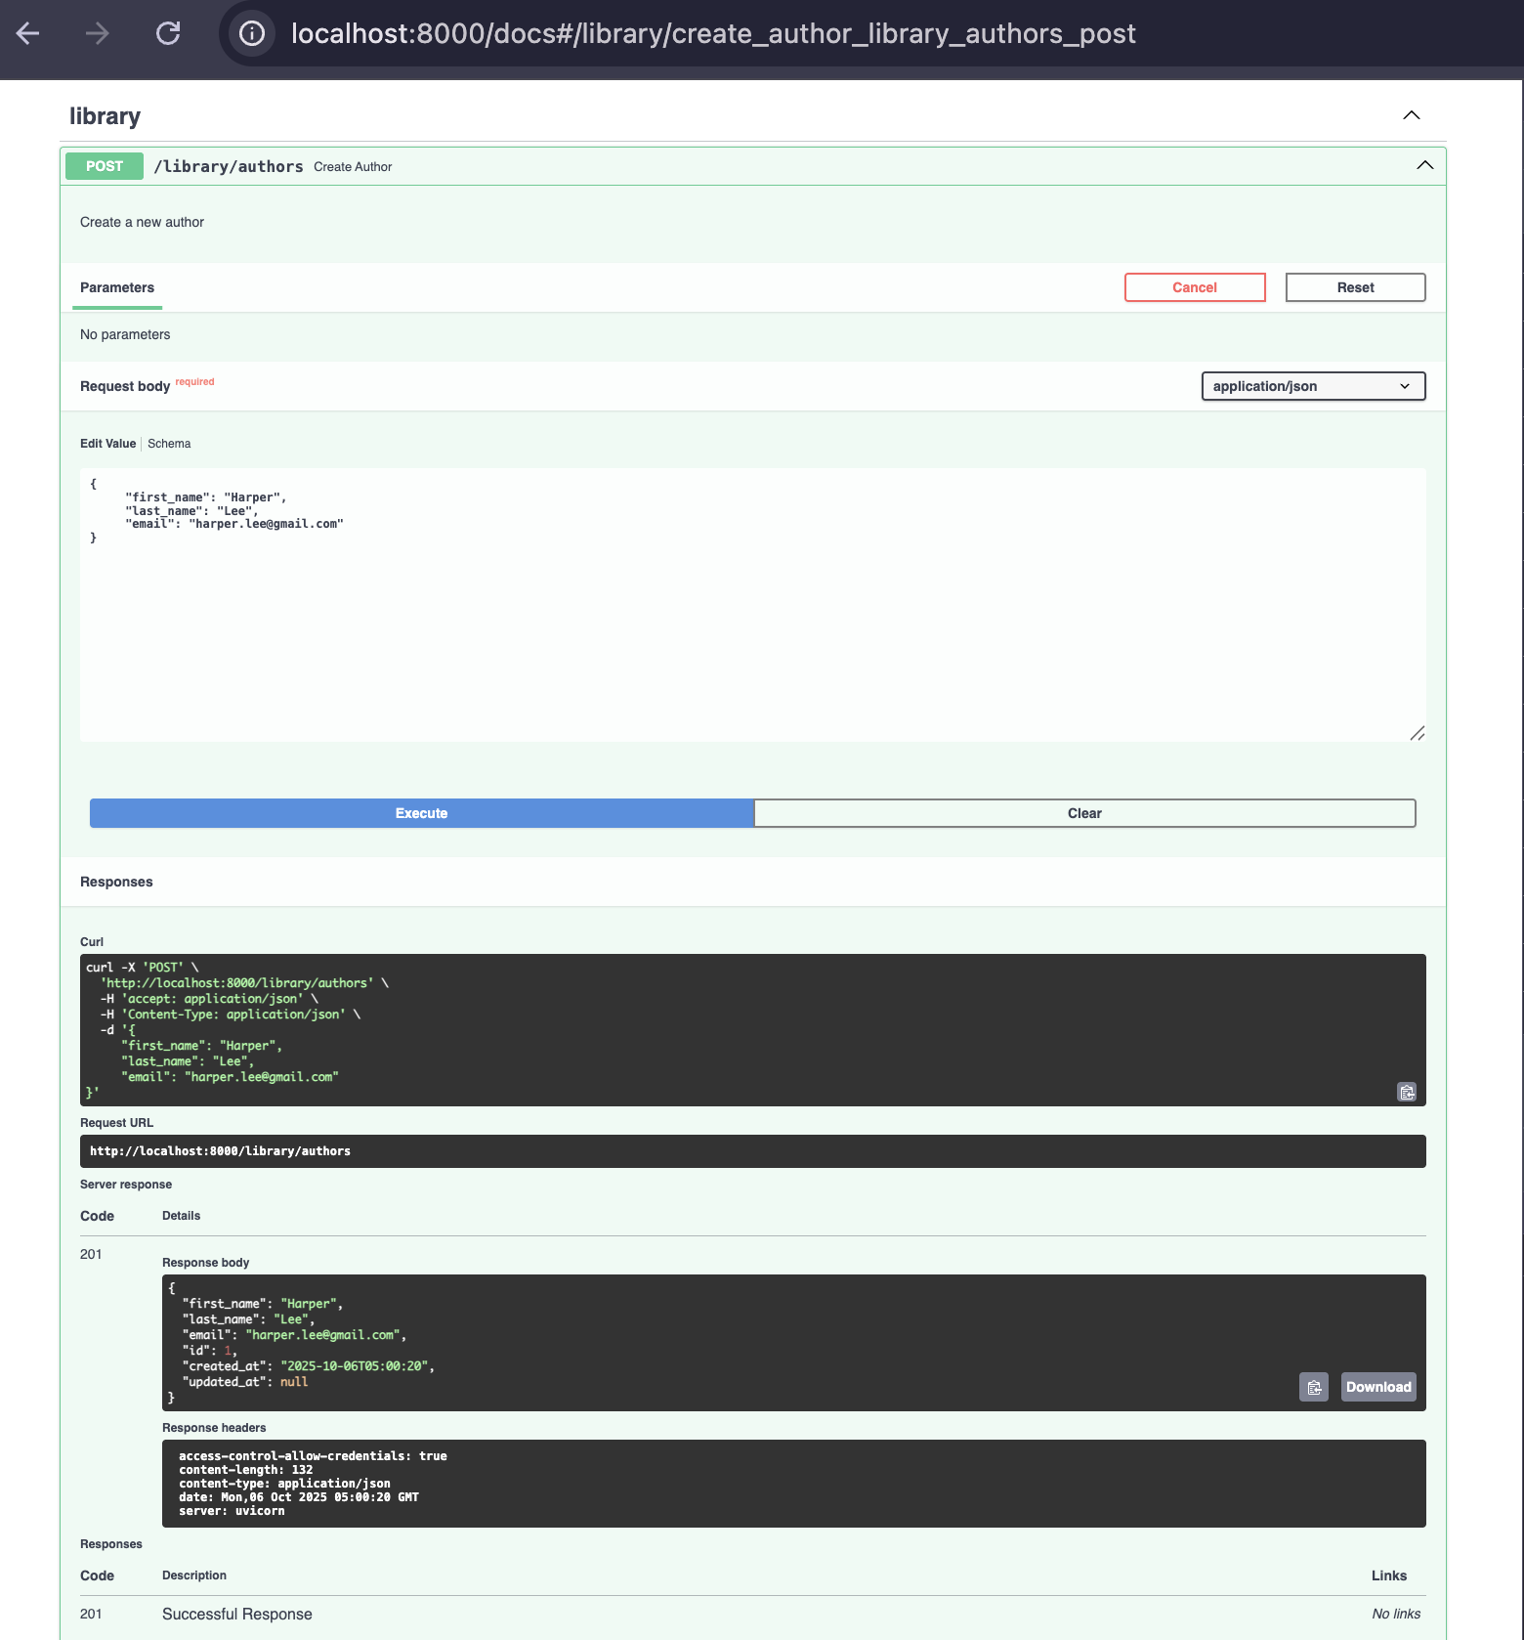

**SQL Screenshots:**

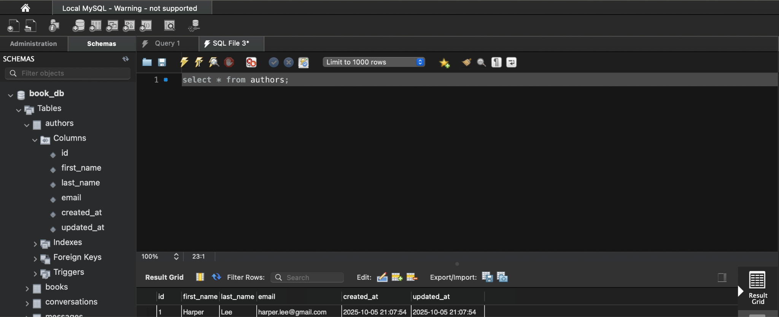

**3. GET /library/authors/{author_id}** - Get specific author

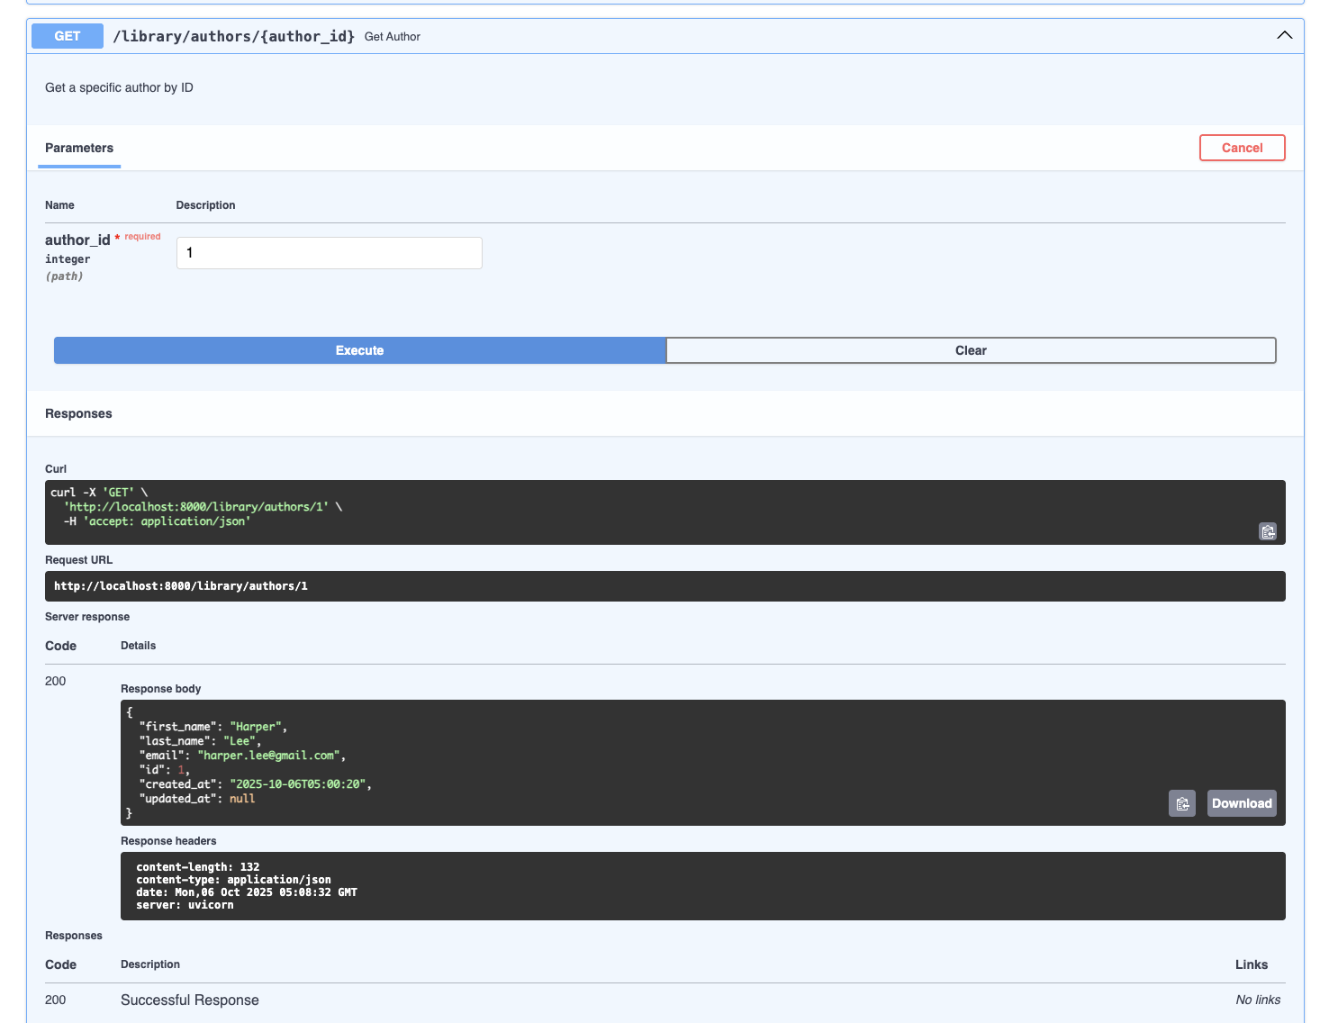

**SQL:**



**4. PUT /library/authors/{author_id} - Update author:**

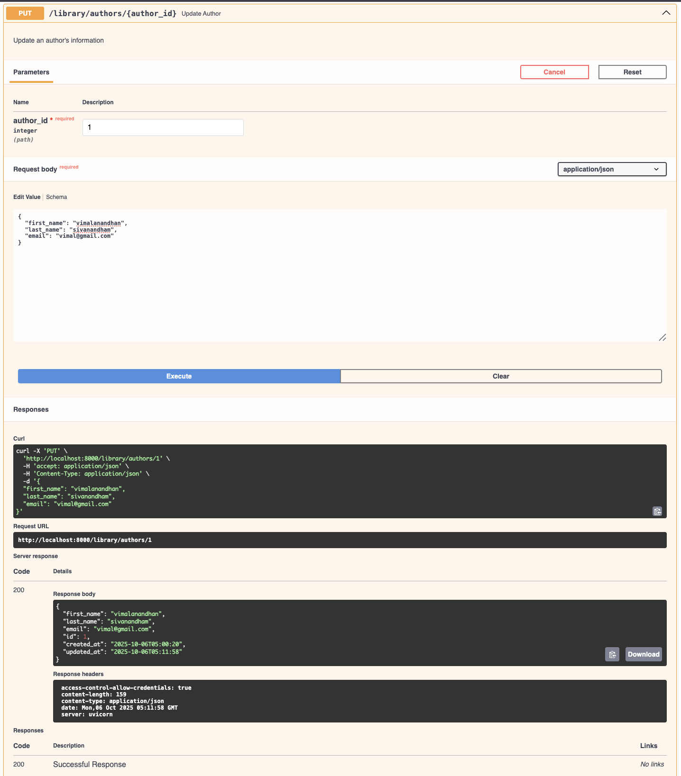

**SQL:**

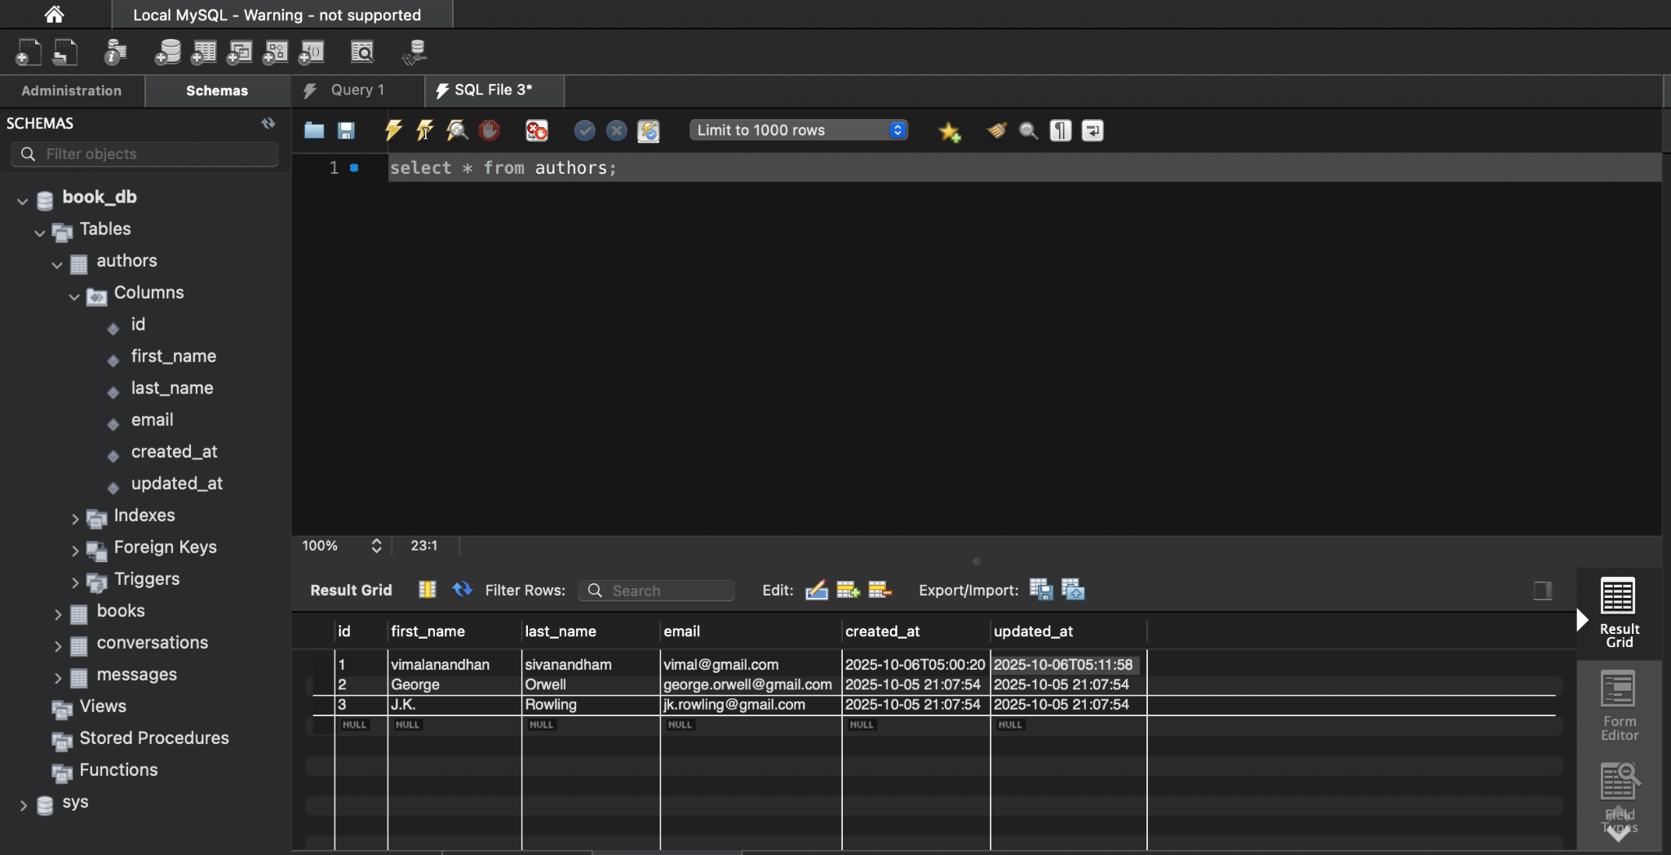

**5. DELETE /library/authors/{author_id} Delete Author**

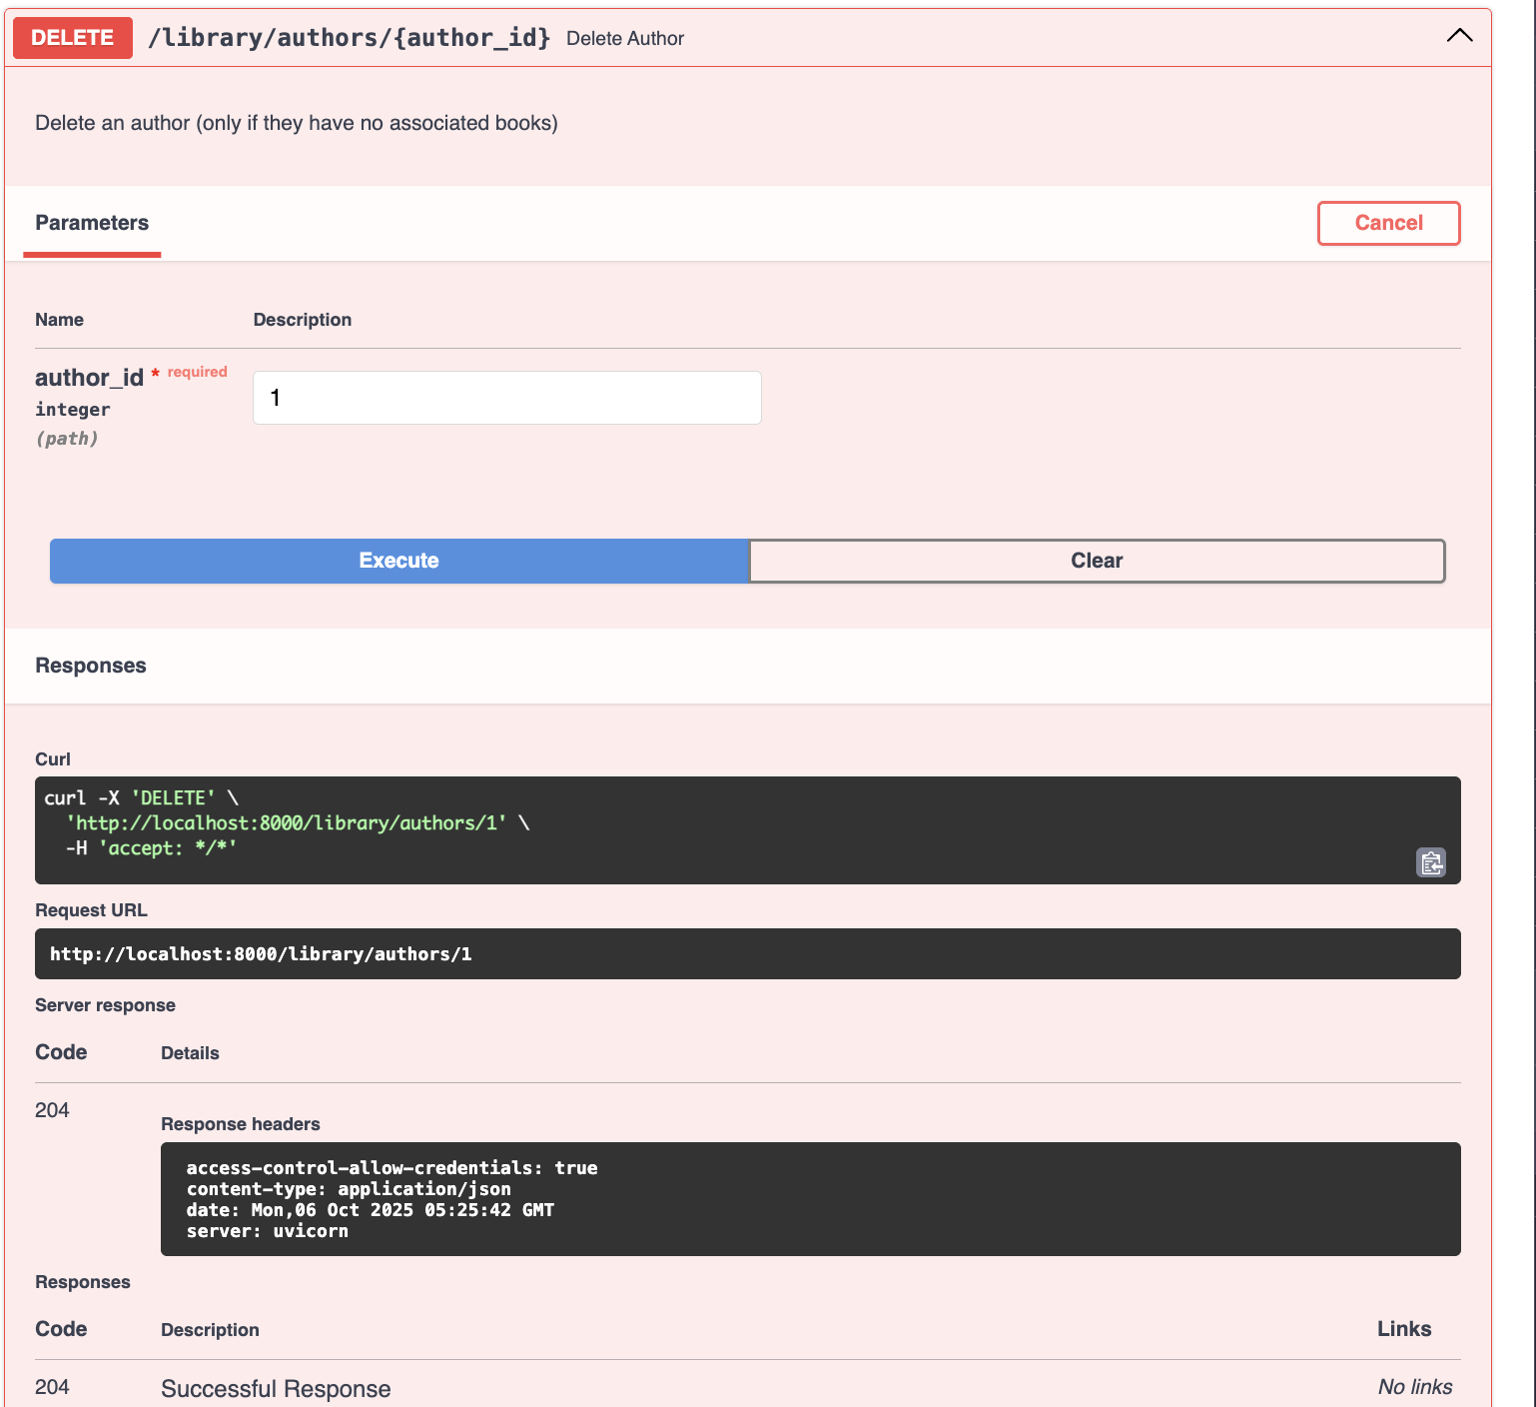

**SQL**

**BEFORE DELETE:**



**AFTER DELETE:**

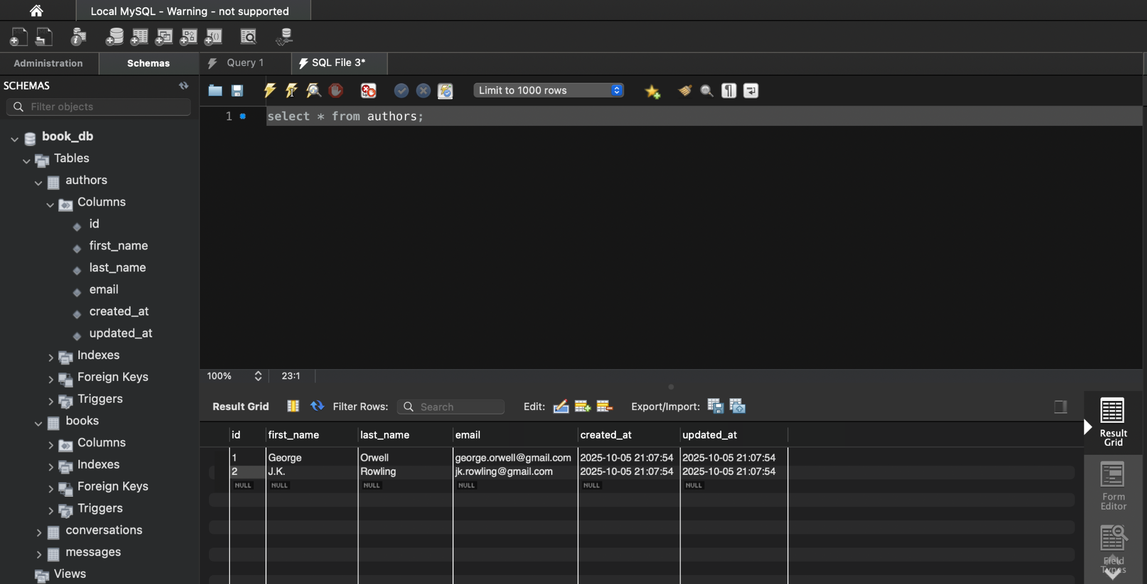

**Books API Endpoint**

**6.POST /library/books** - Create new book

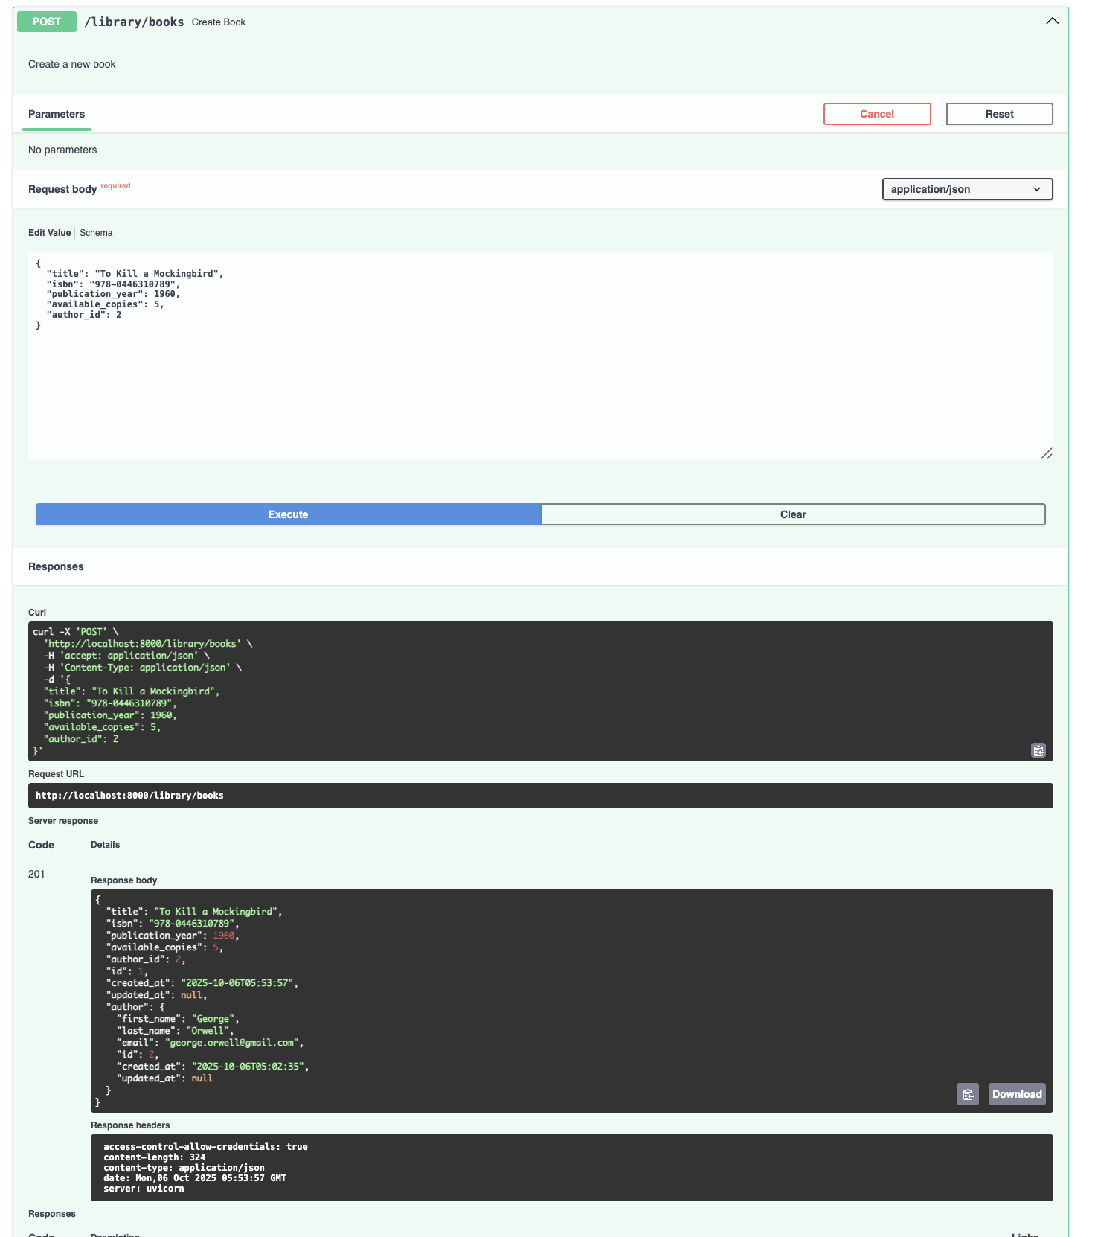

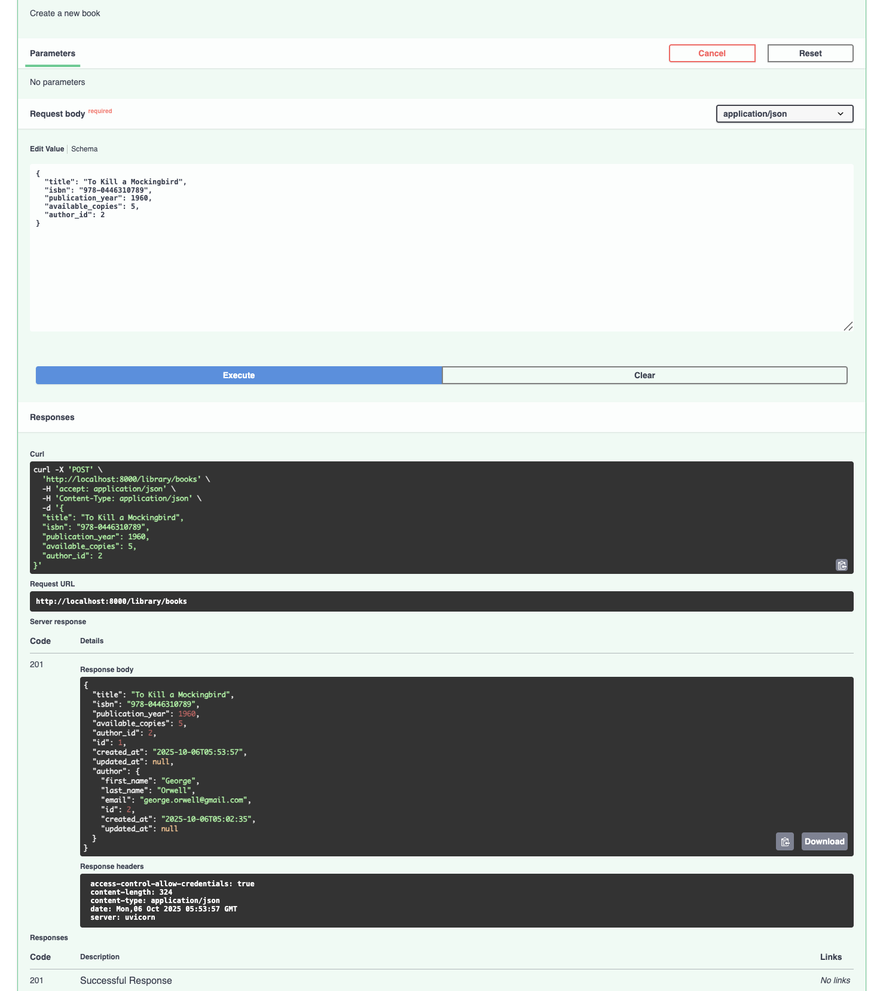

**SQL:**

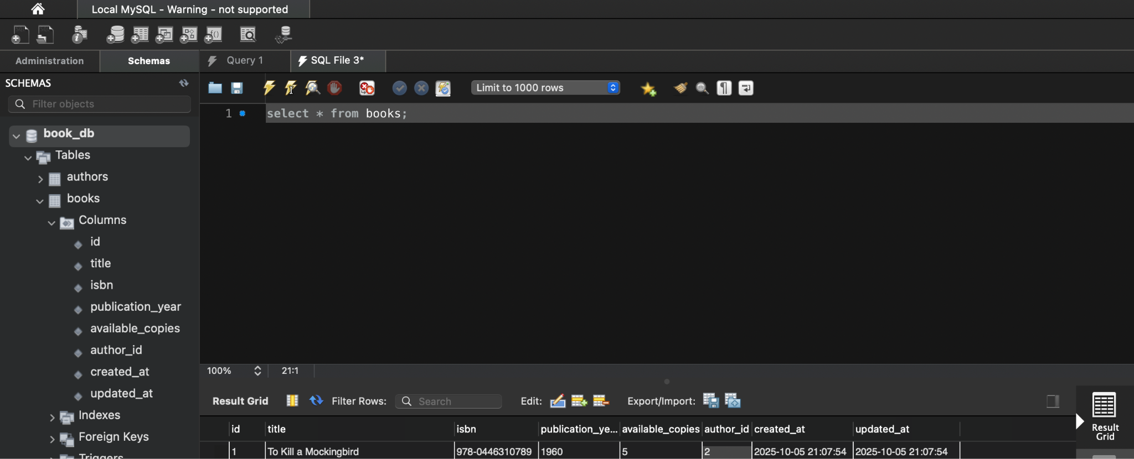

**7.GET /library/books** - Get all books

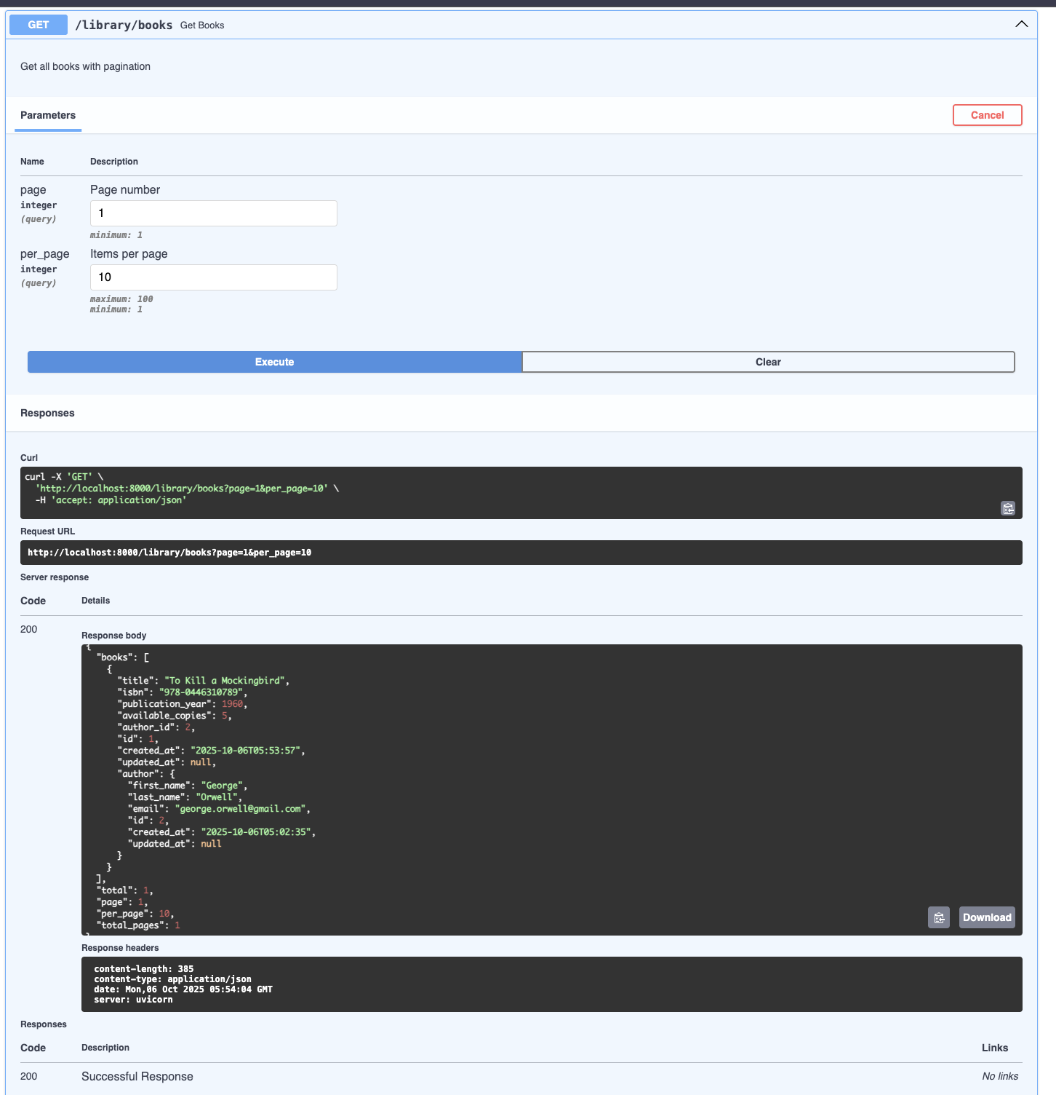

**SQL:**



**8.GET /library/books/{book_id}** - Get specific book

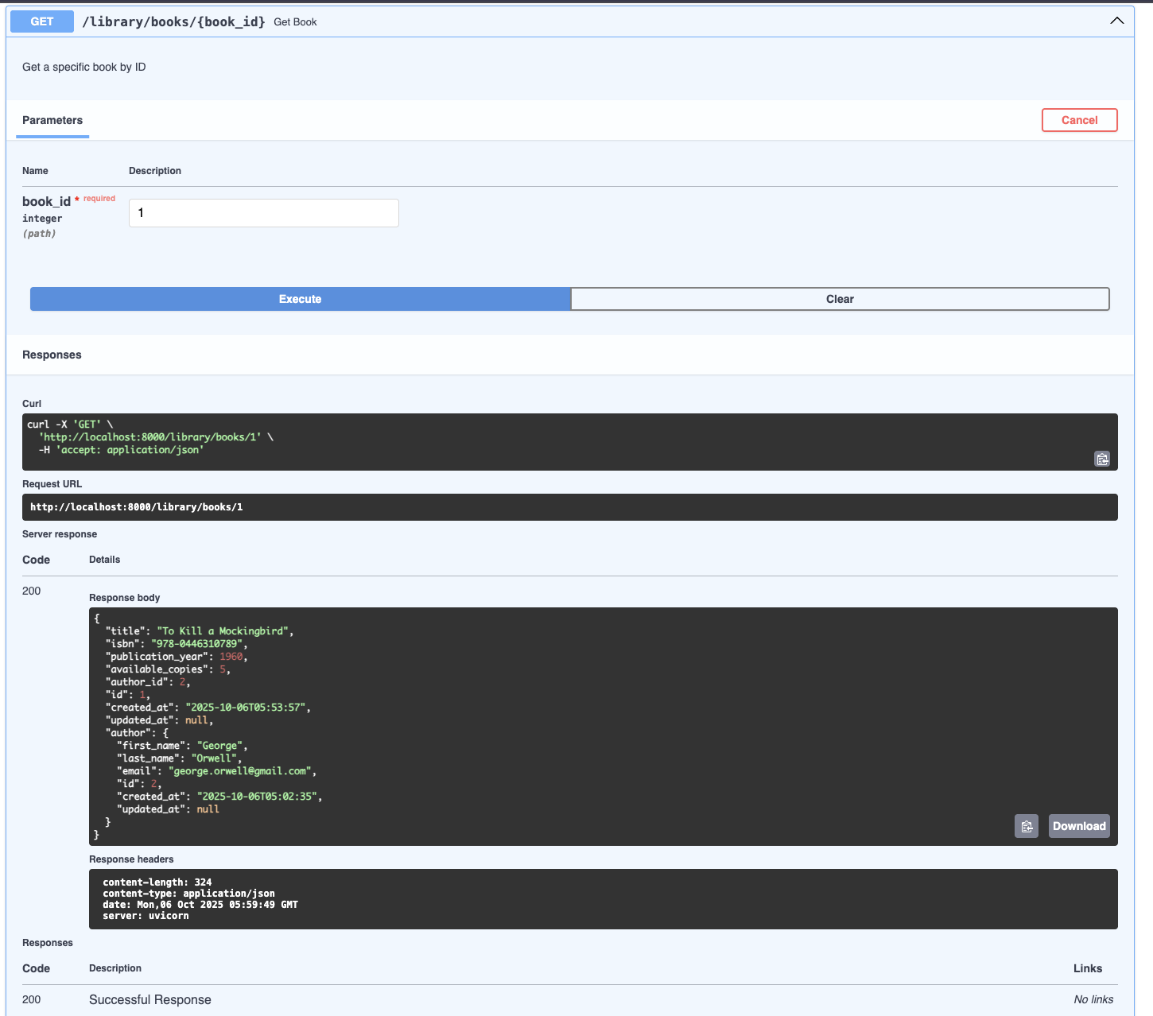

**SQL:**



**9.GET /library/authors/{author_id}/books** - Get books by author

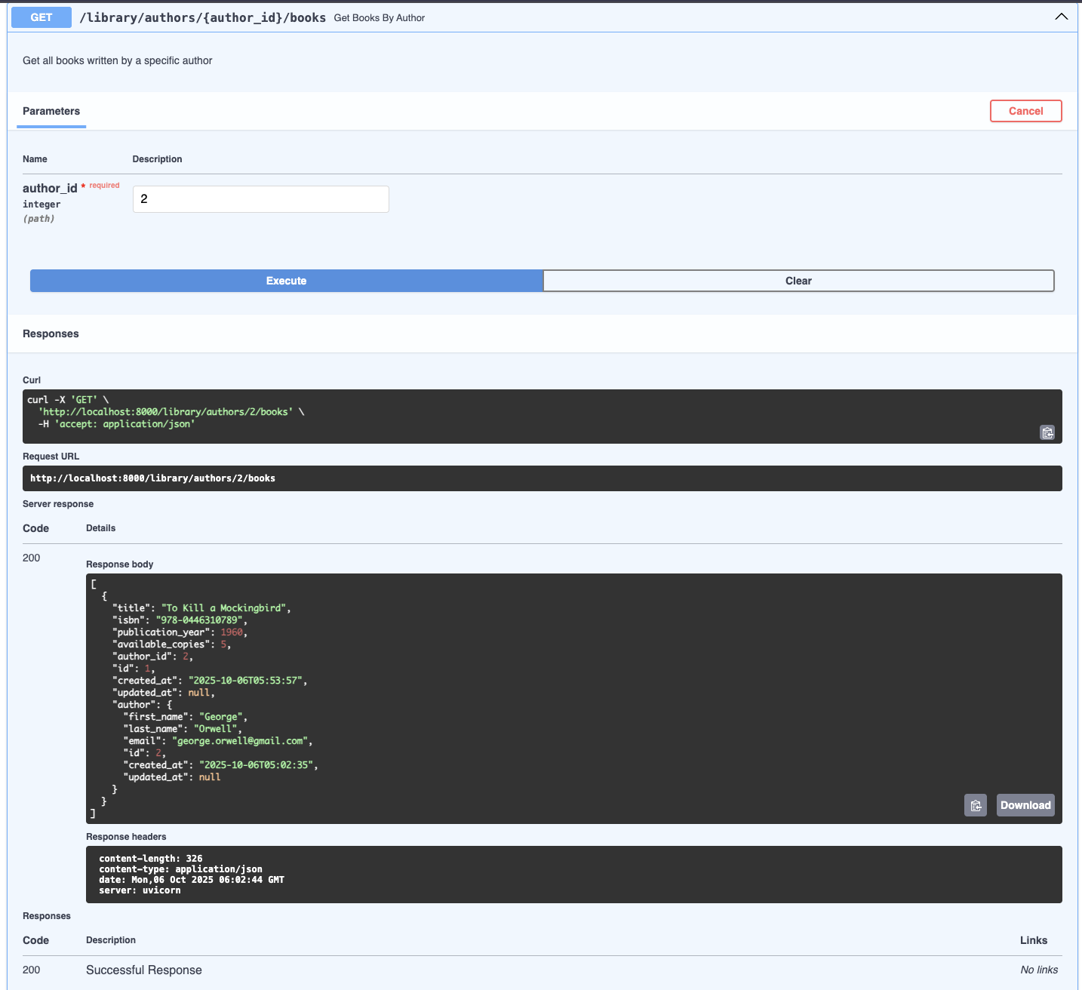

**SQL:**

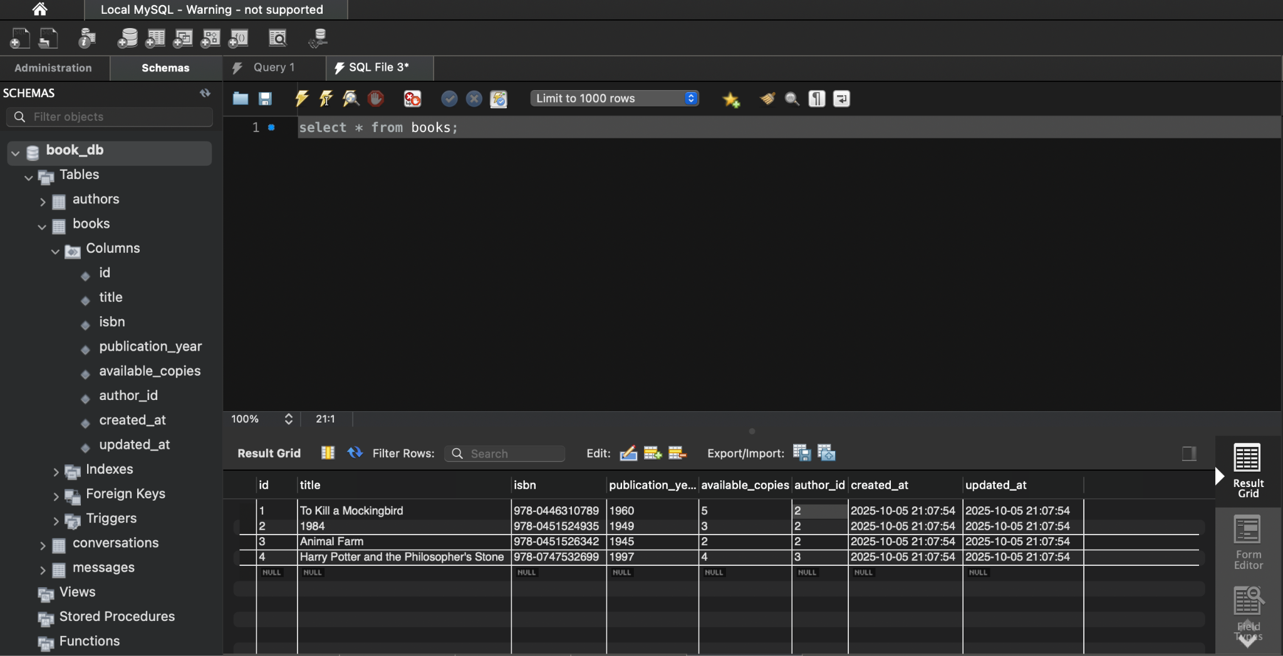

**10.PUT /library/books/{book_id} - Update book**

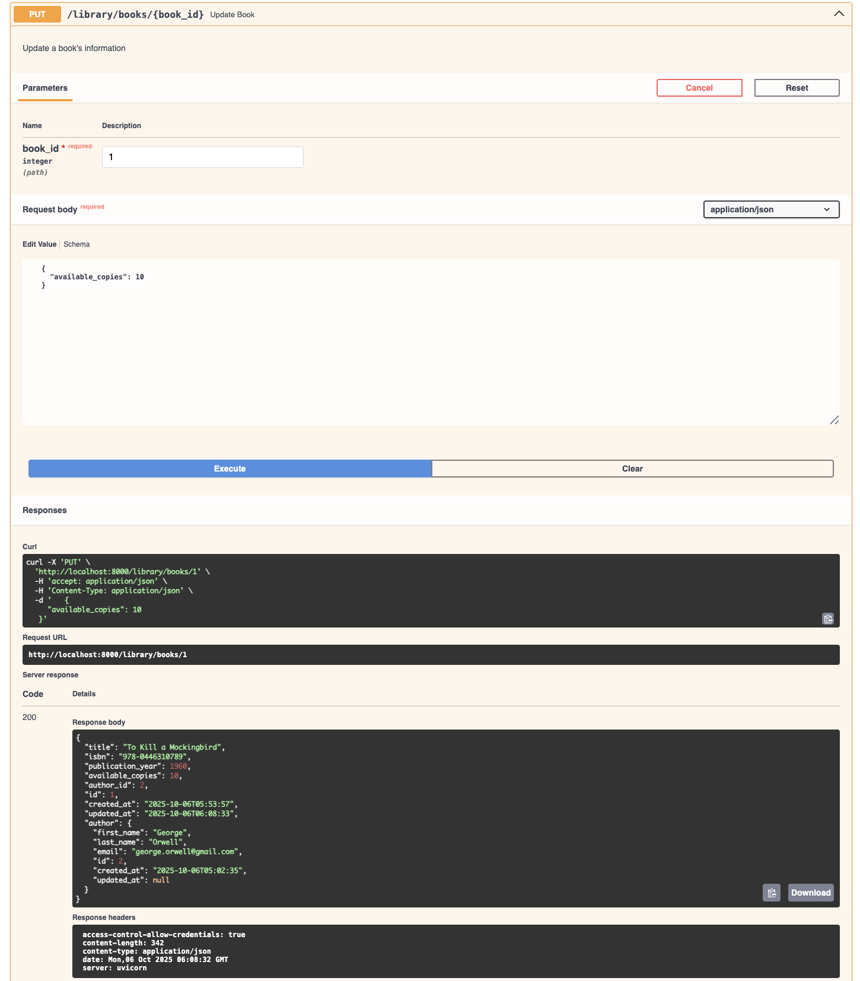

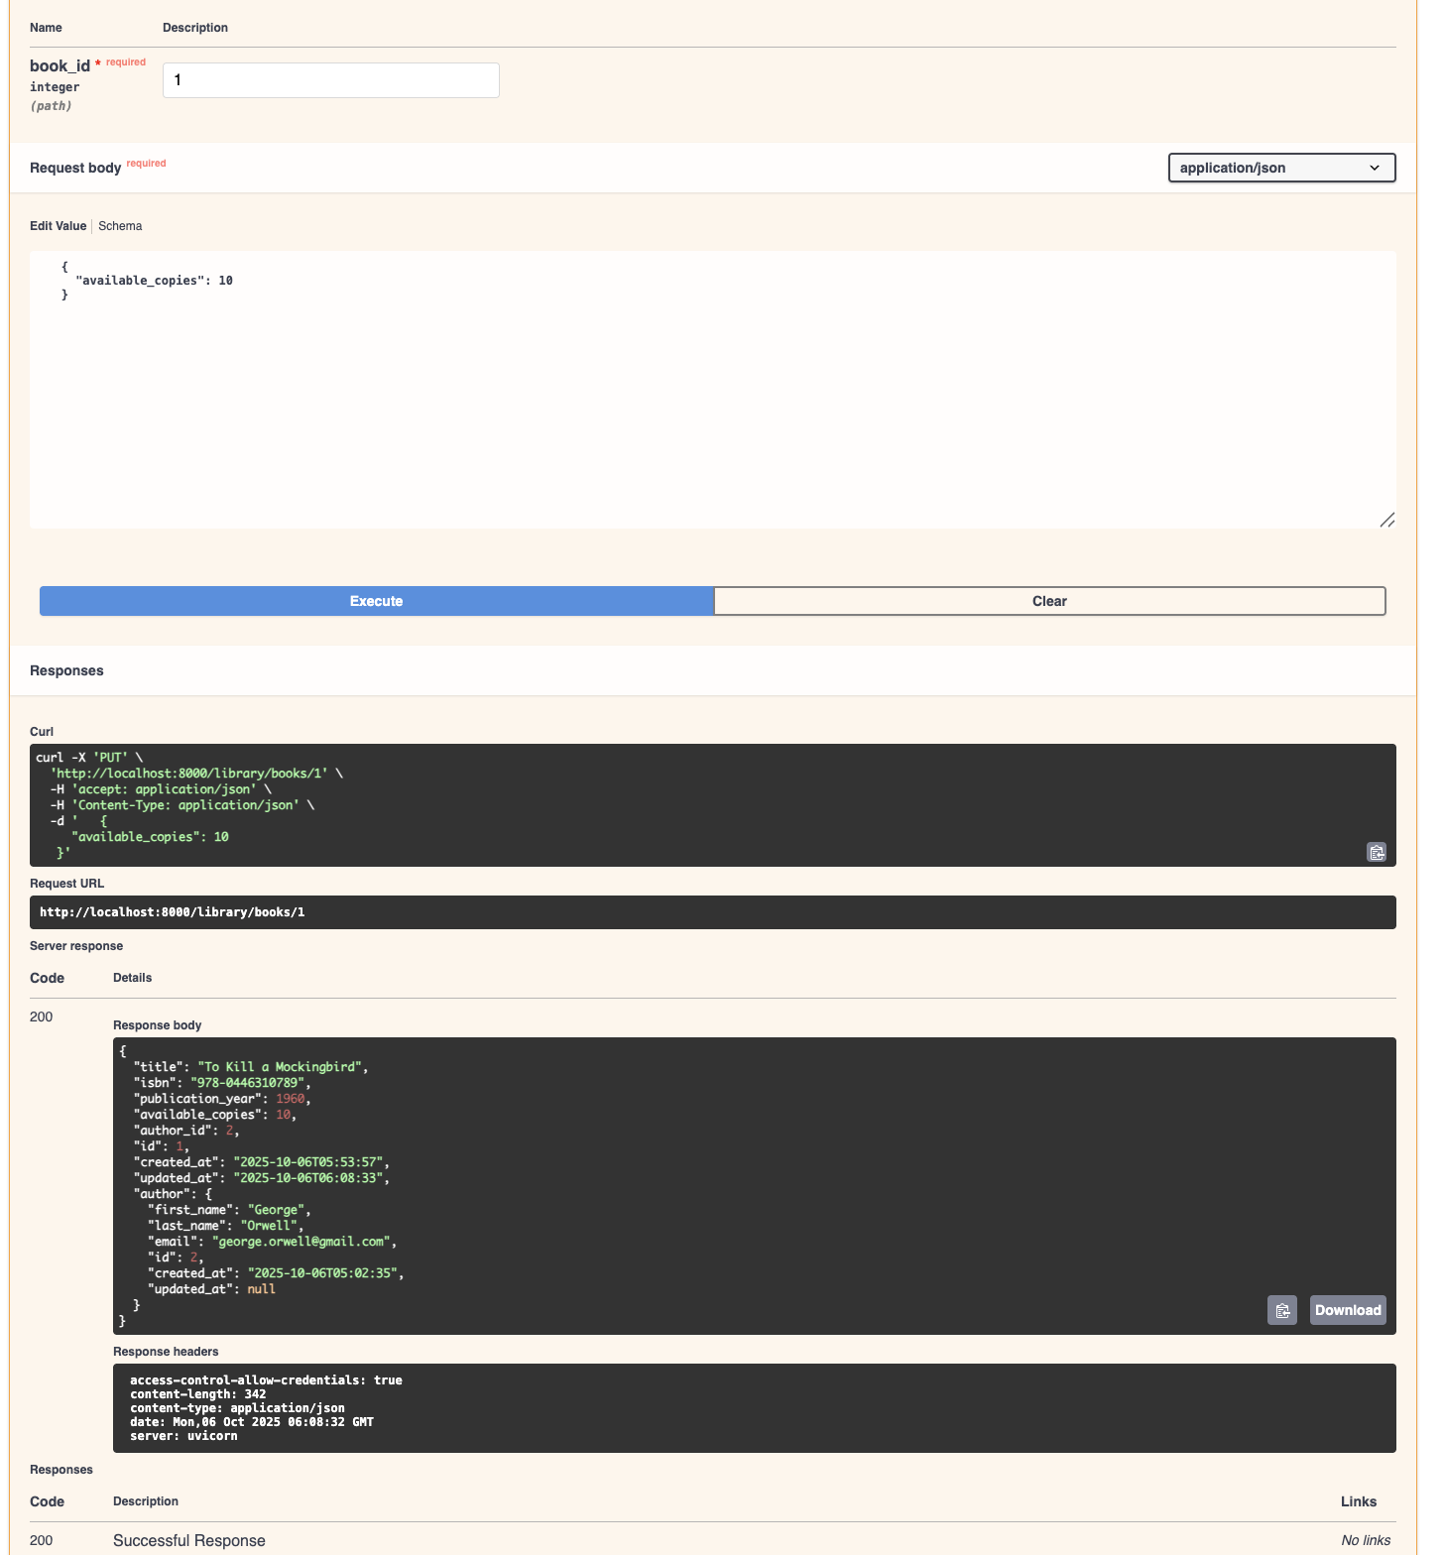

**SQL:**

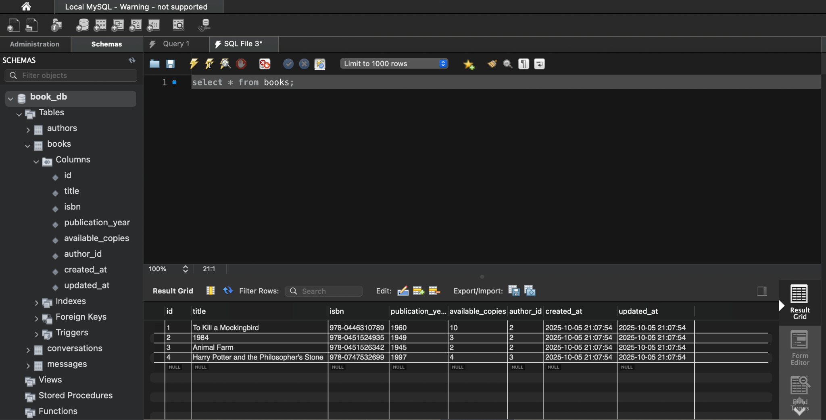

**11.DELETE /library/books/{book_id} - Delete book**

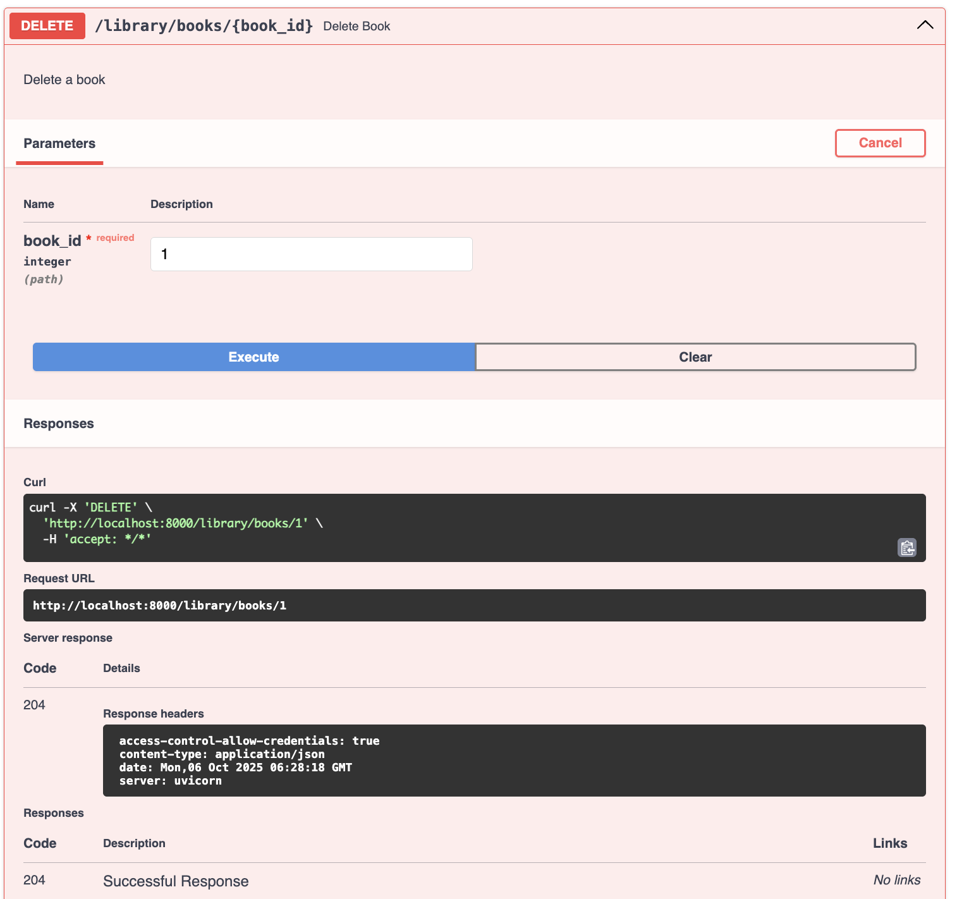

**12.Test Duplicate Email**

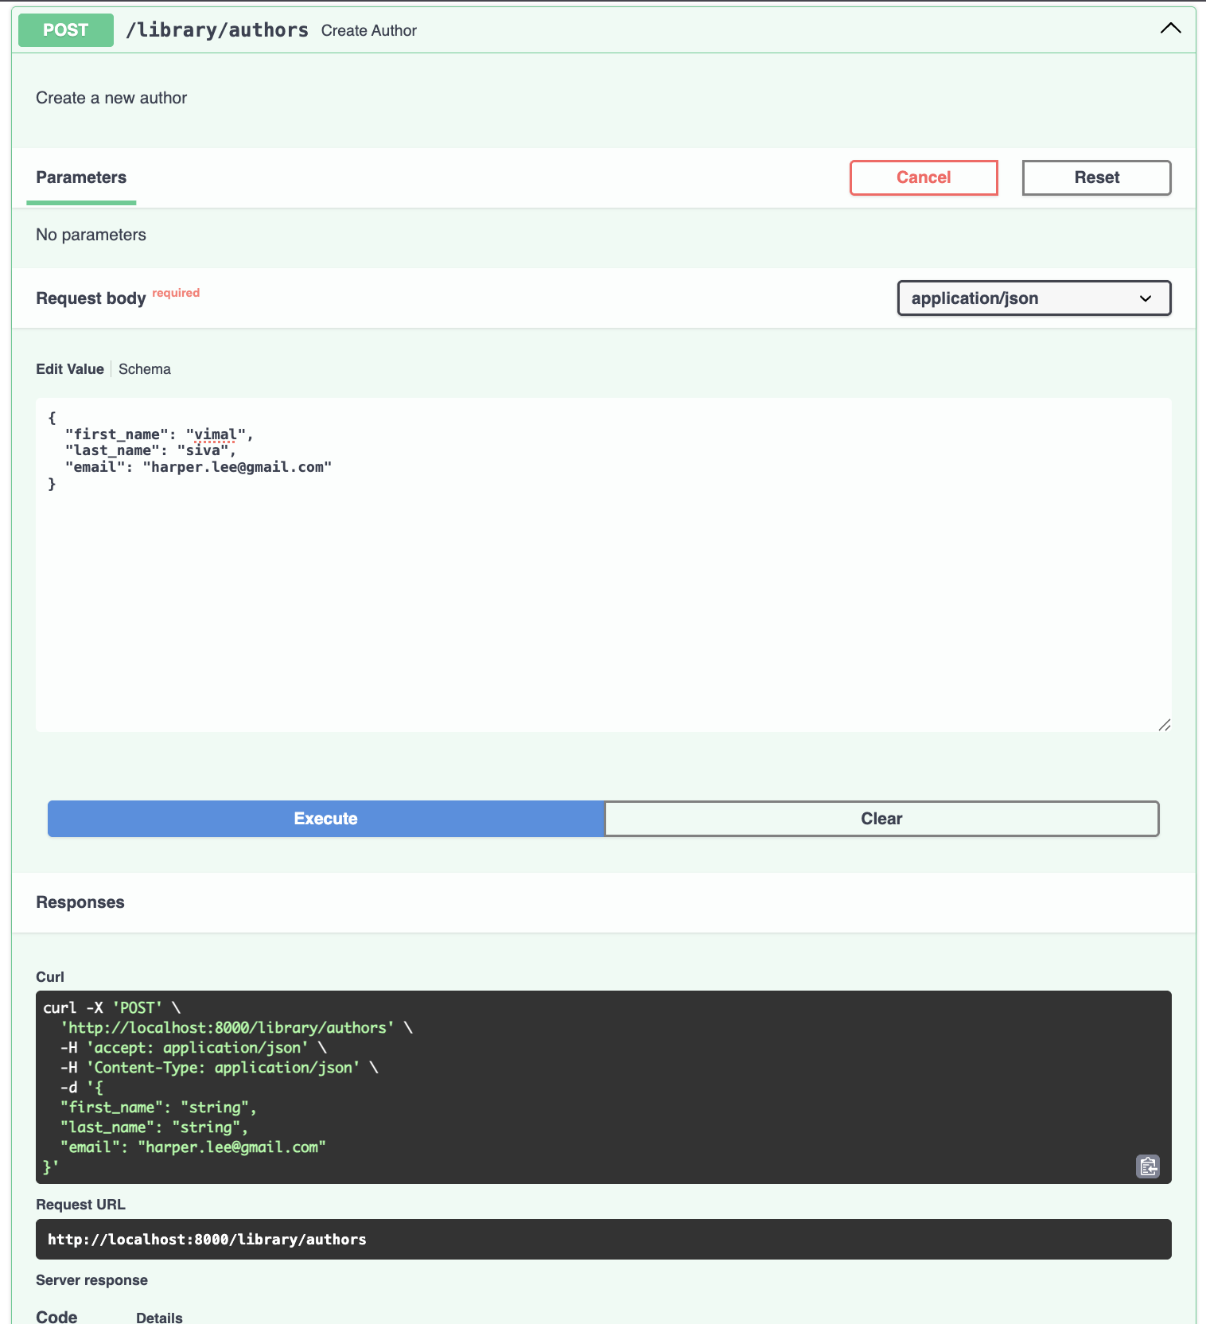

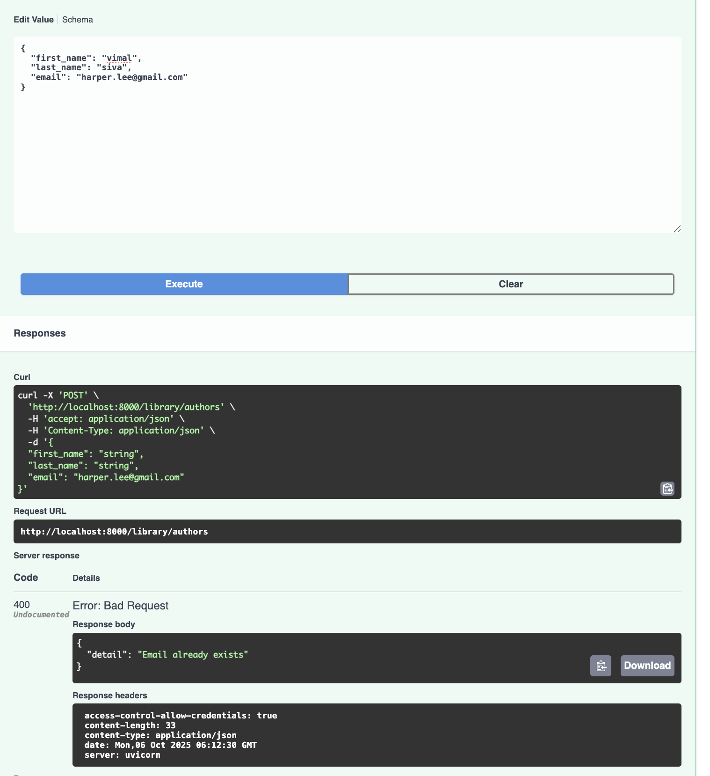

**We used the same email address before which is already available in the db as below. That's the reason the status code and response body is throwing errors.**

**SQL:**

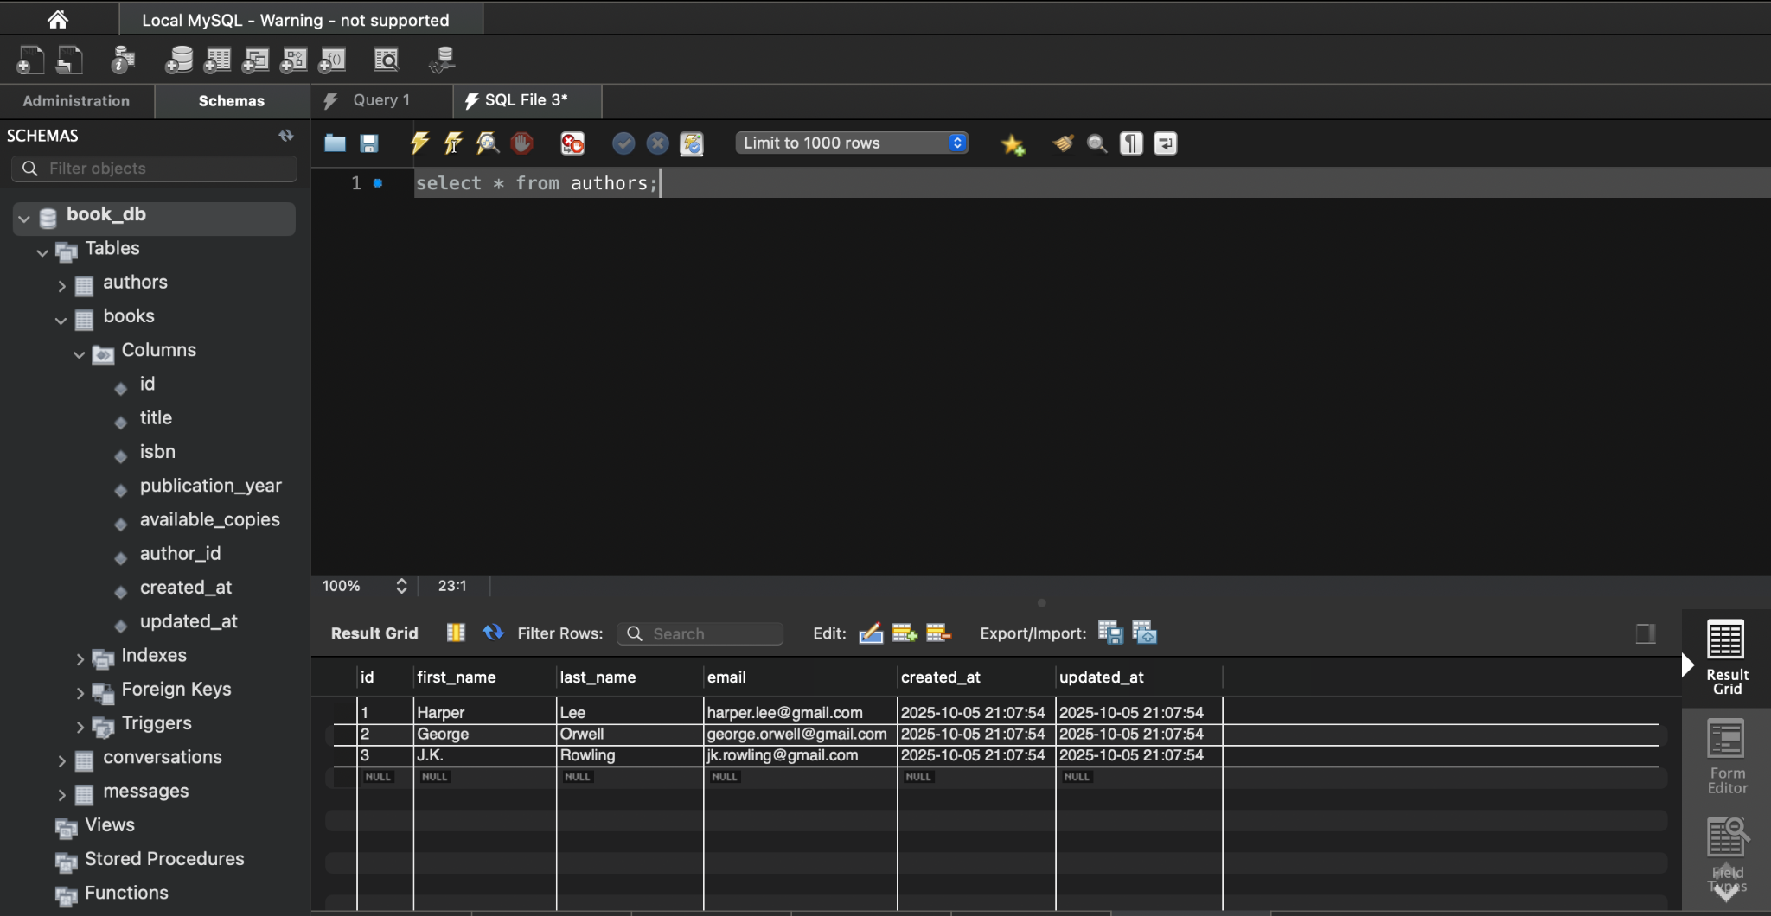

**13. Test Duplicate ISBN**

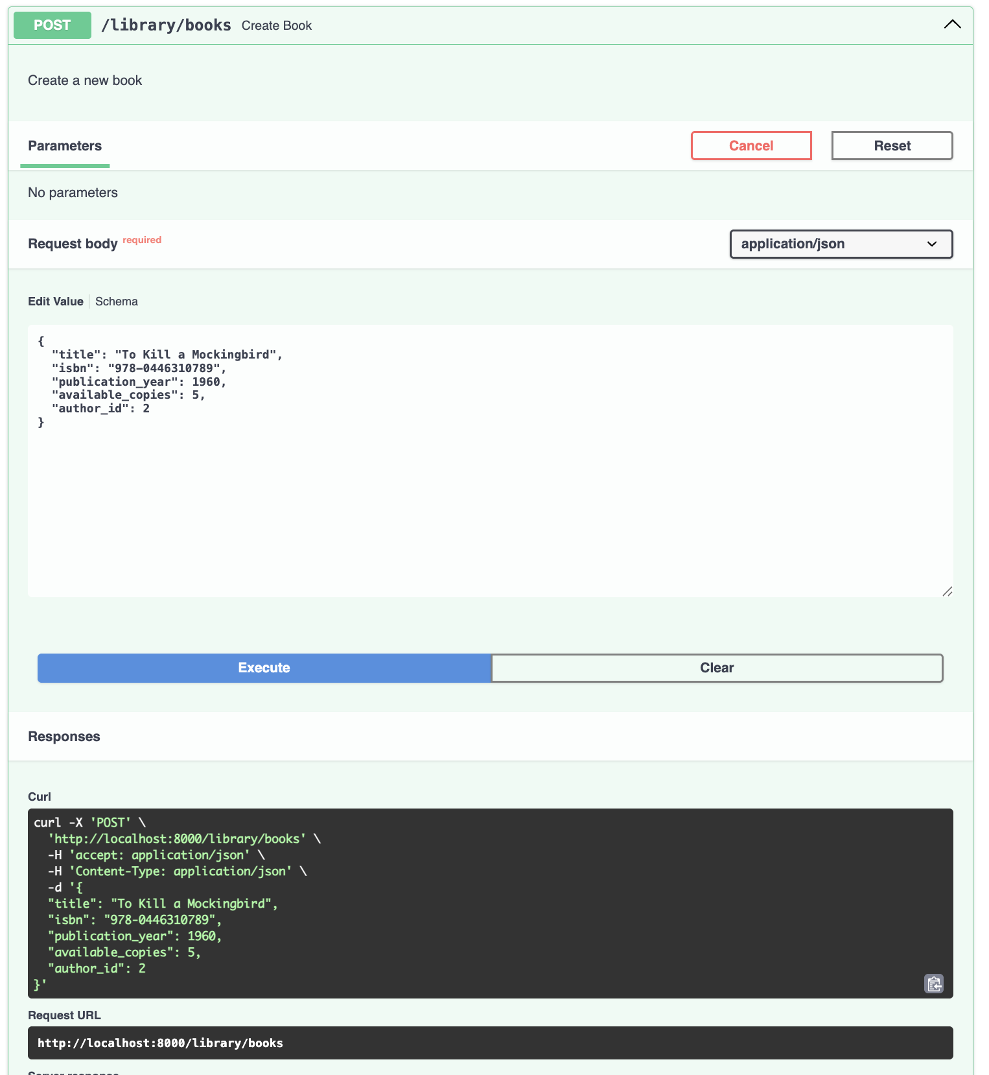

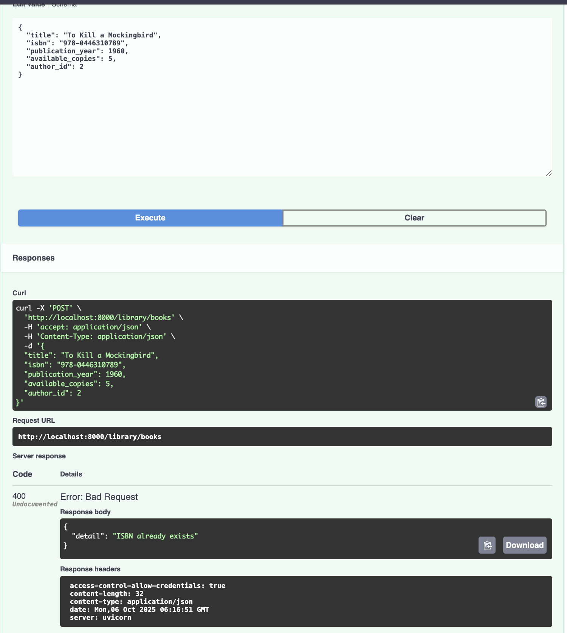

**We used the same ISBN before which is already available in the db as below. That's the reason the status code and response body is throwing errors.**

**SQL:**

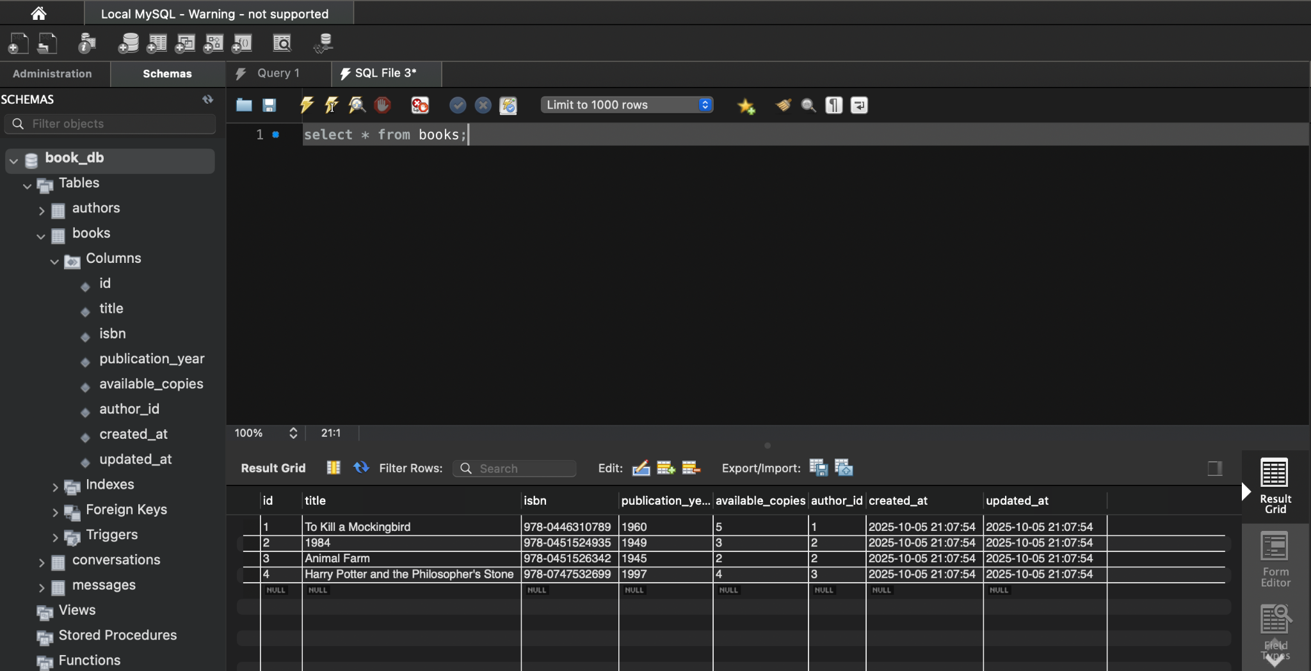

**14.Test Author Deletion with Books - Try deleting an author who has books**

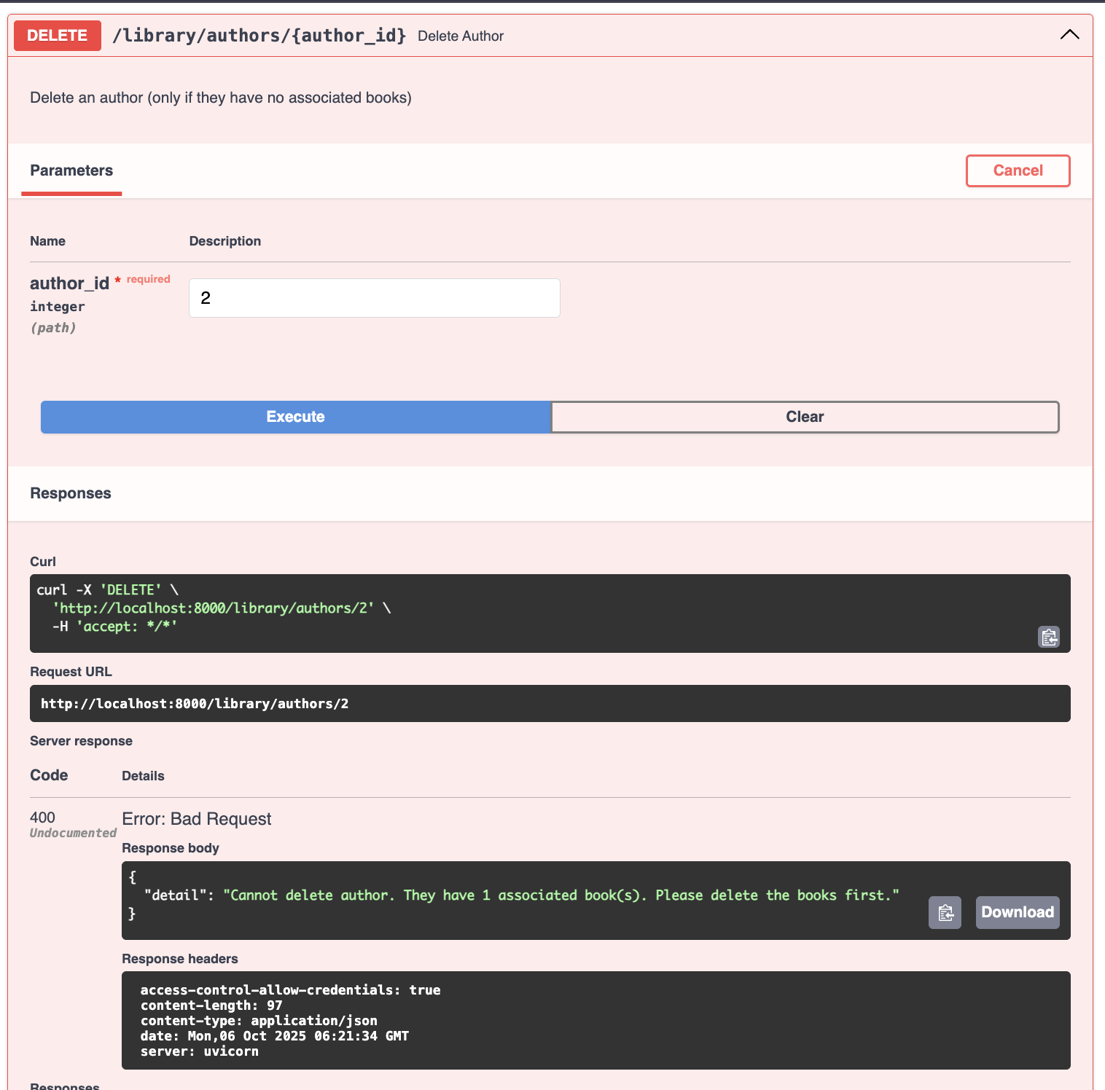

**We tried to delete the author who has the books tagged under their id so ,we won’t be able to delete it, we need to delete the book first as available in the db as below. That's the reason the status code and response body is throwing errors.**

**SQL:**

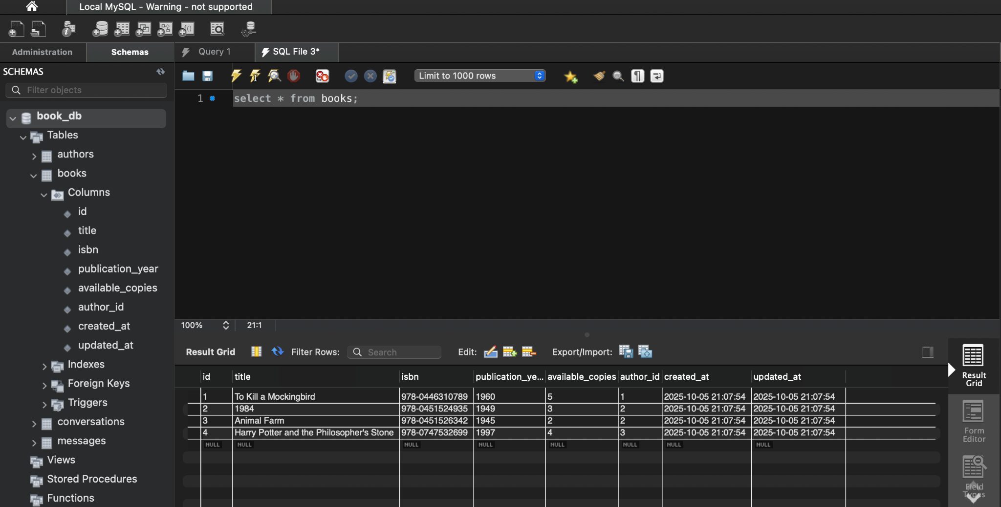

**SQL TABLES:**

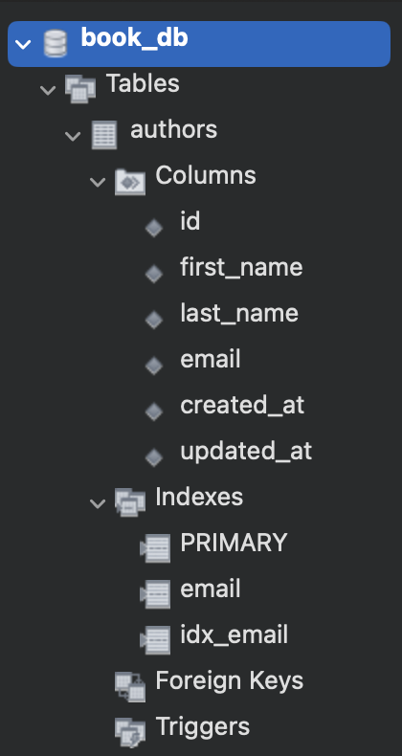

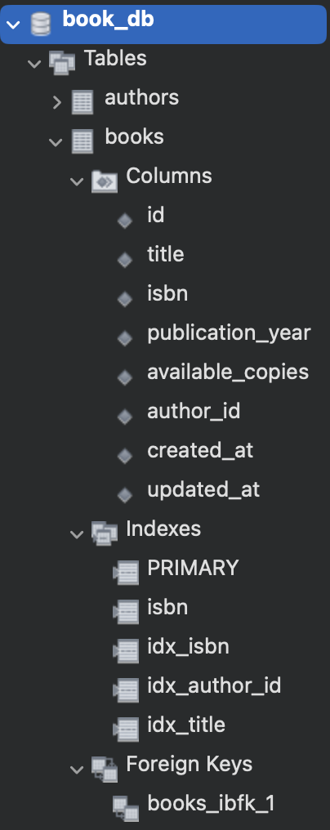

**PART -2**

1. Redux and Axios axis
   * Used Axios to make the API calls.

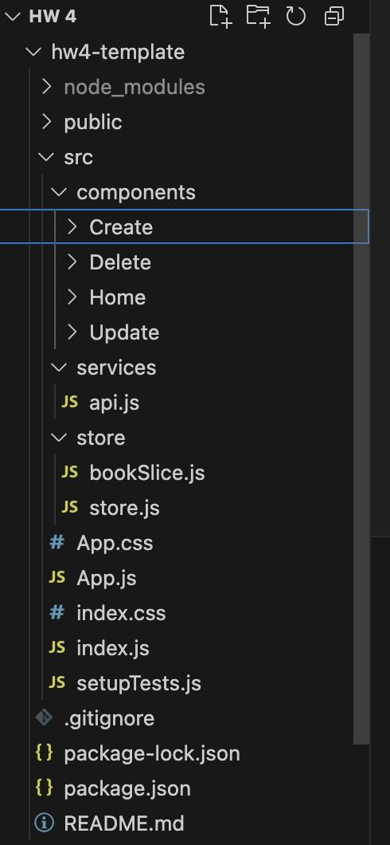

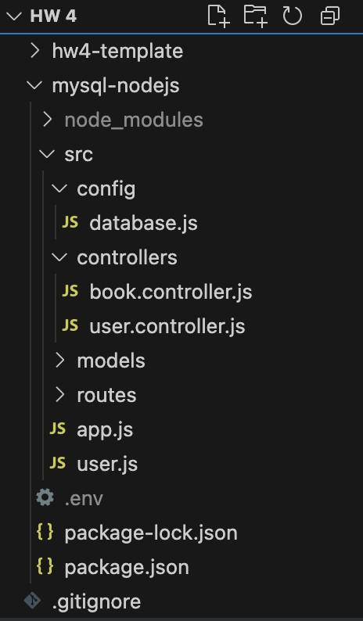

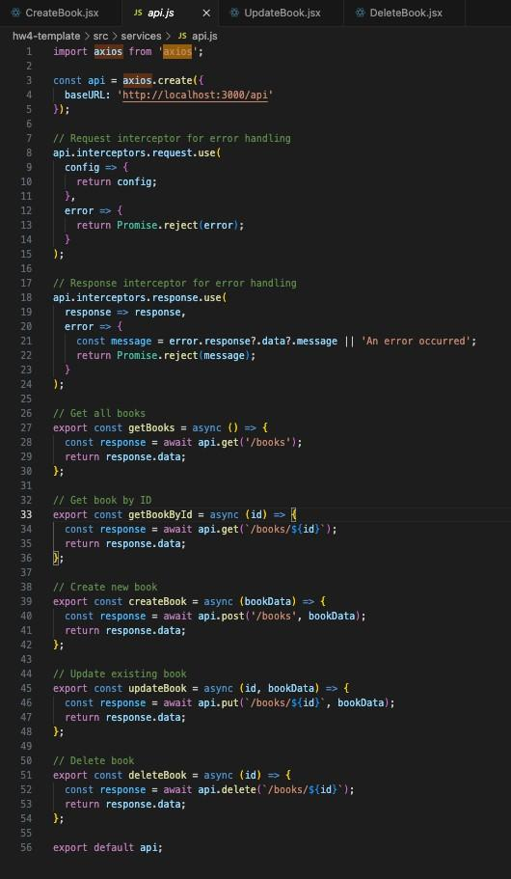

**NOTE: I have used Reduxjs Toolkit**

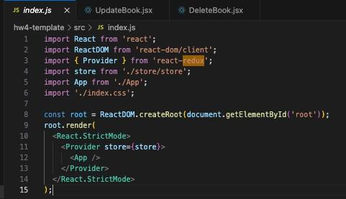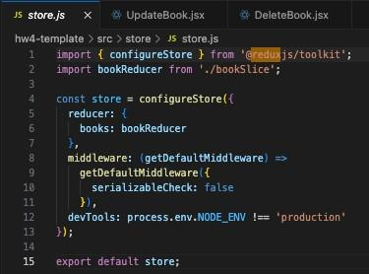

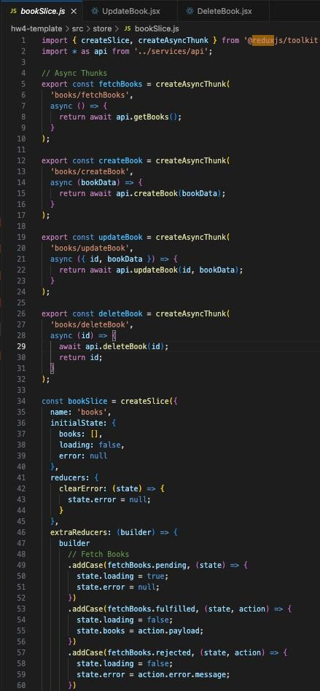

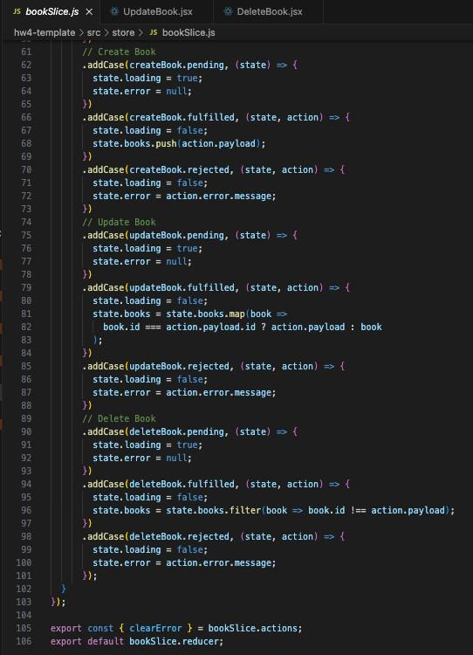

Home Screen

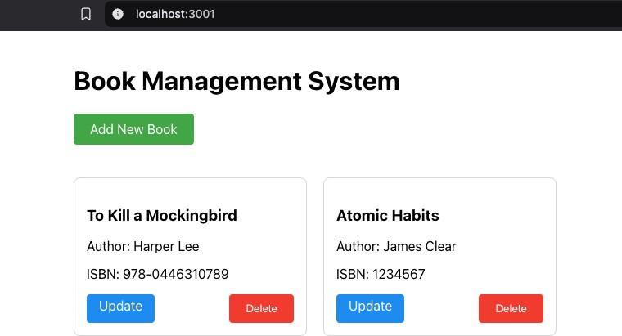

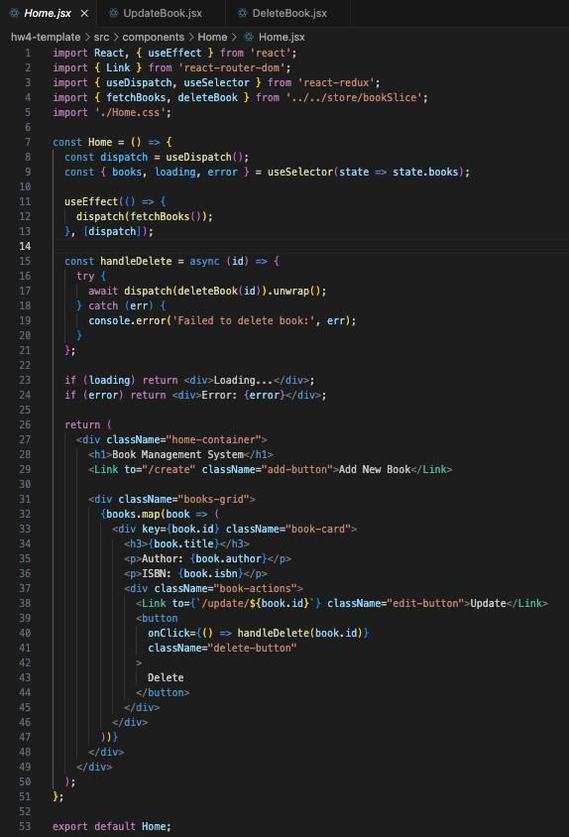

Create Screen 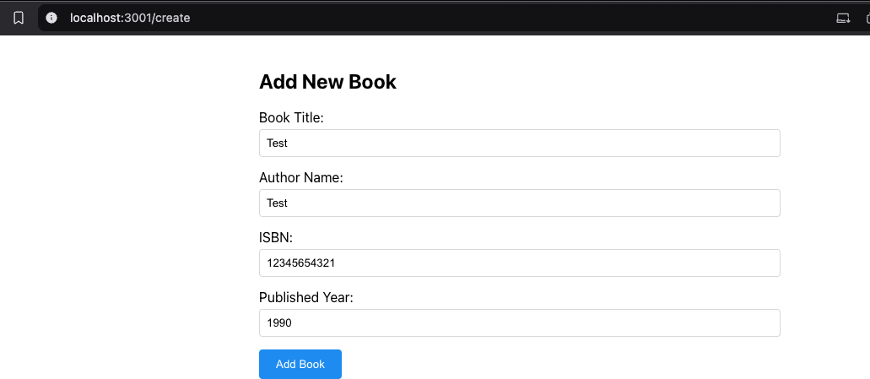

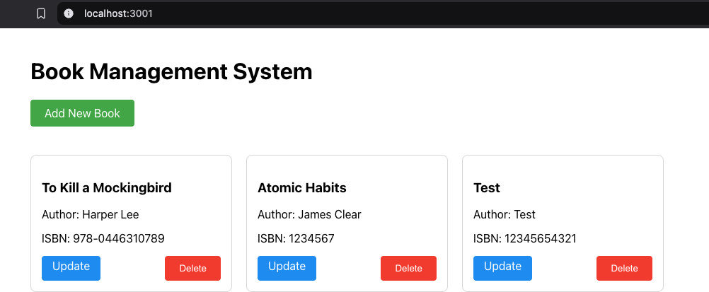

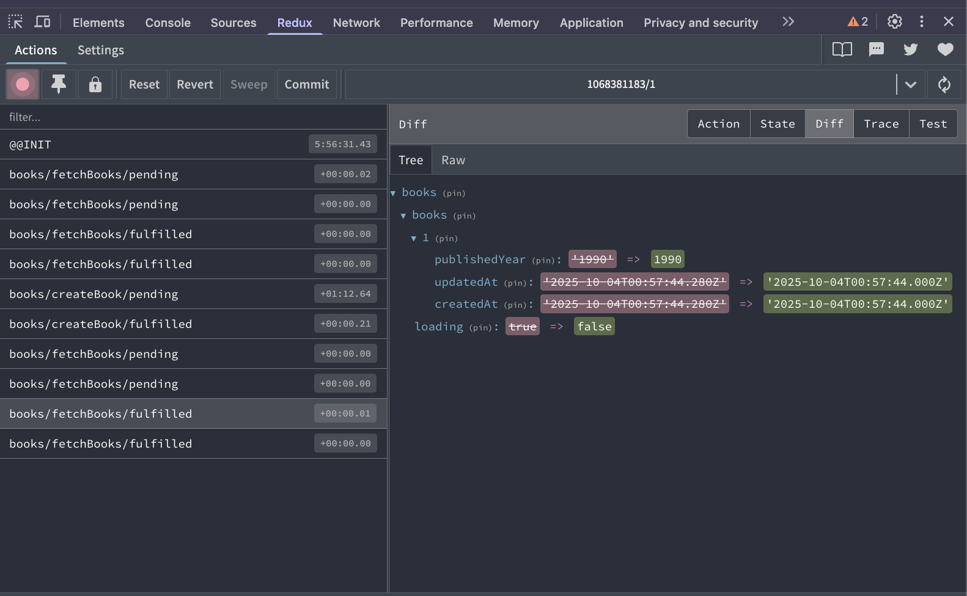

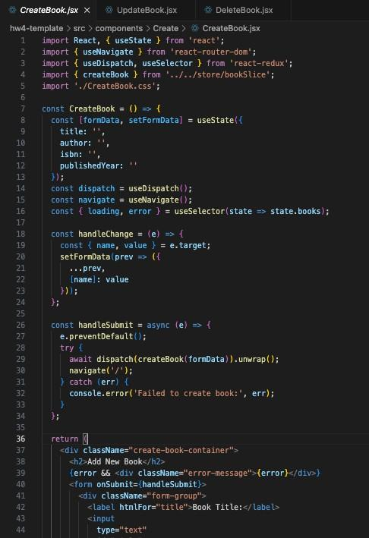

Update Screen

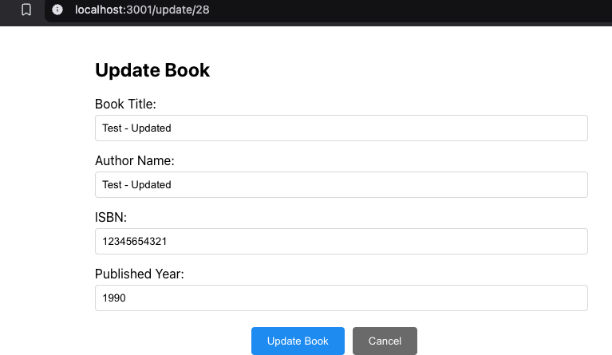

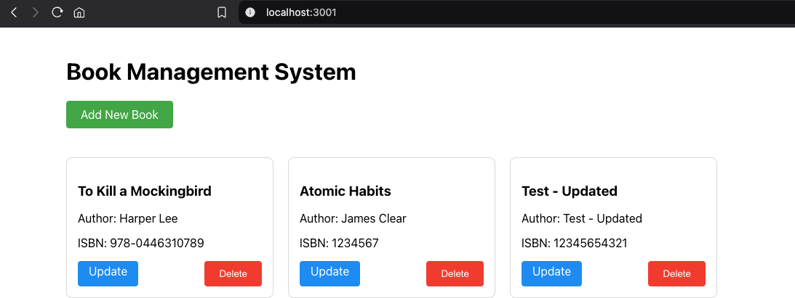

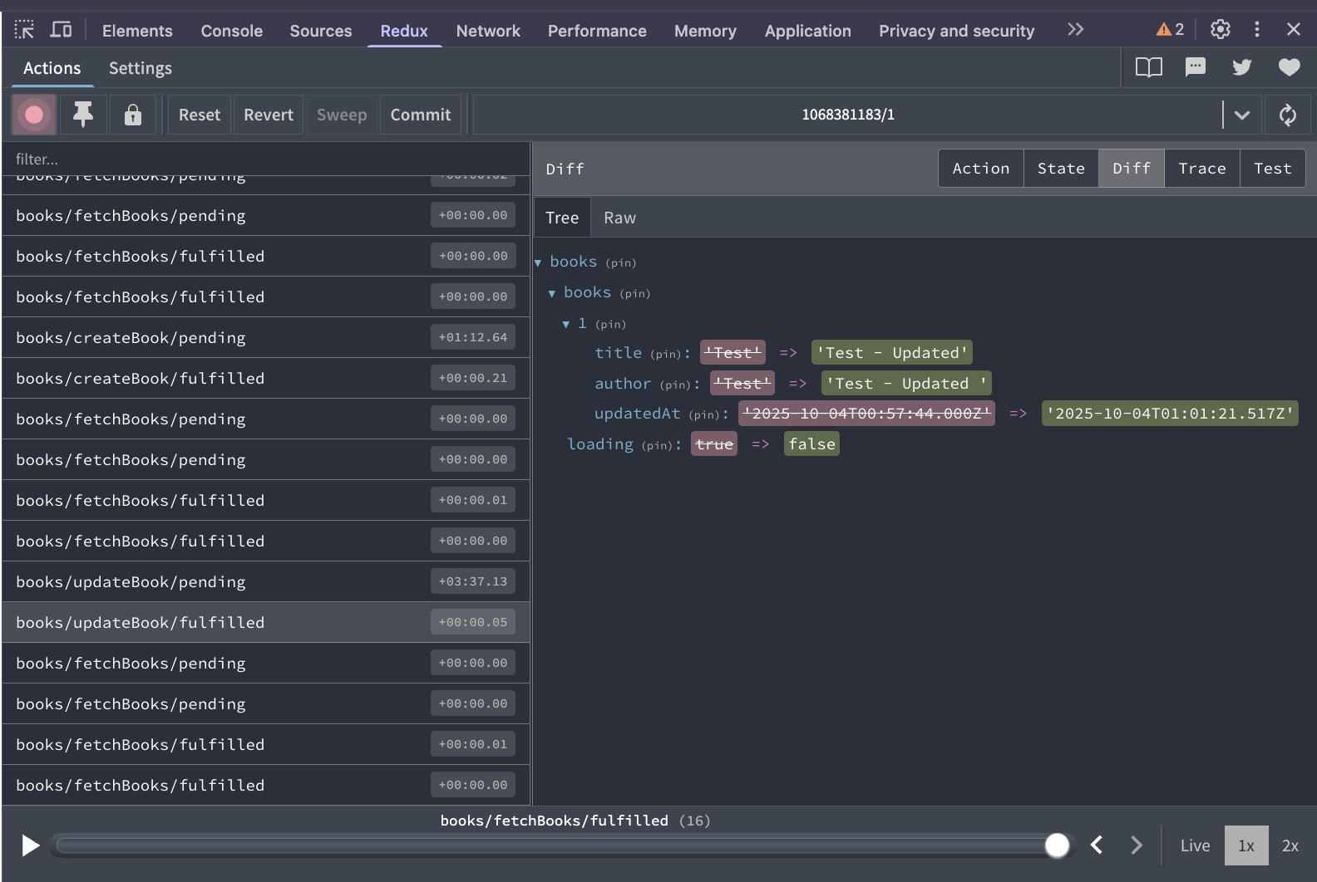

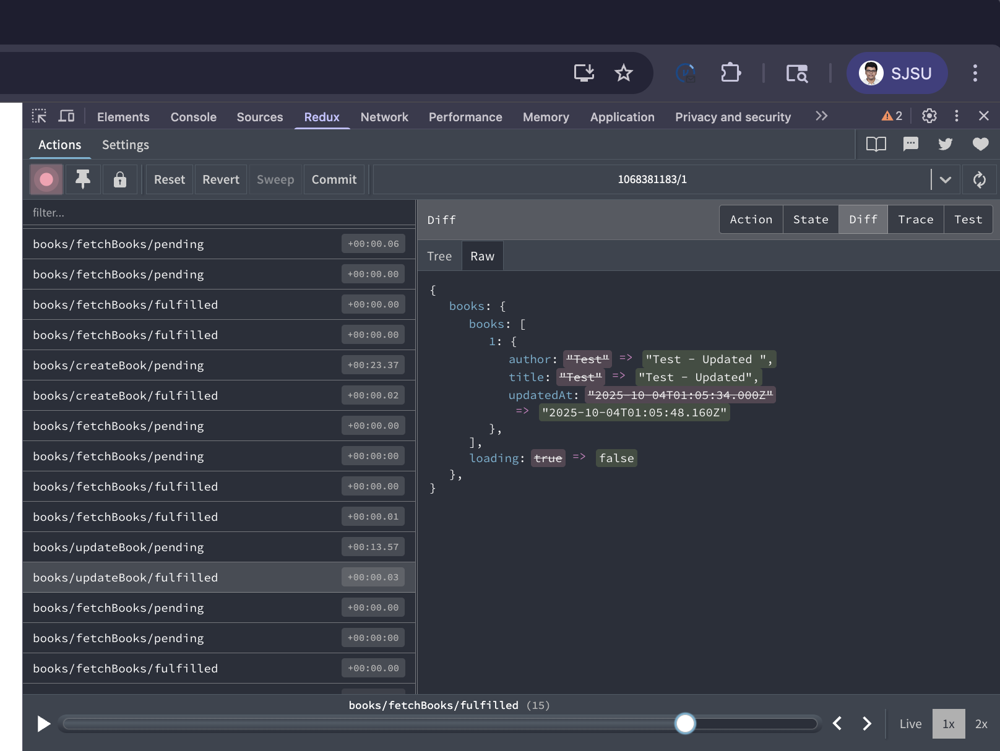

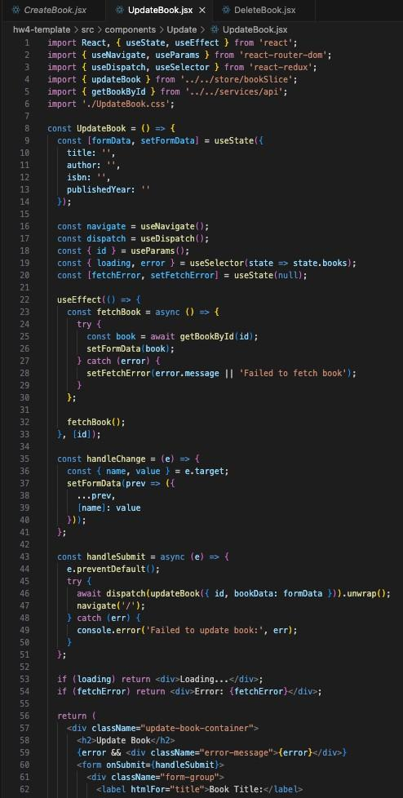

Delete Screen 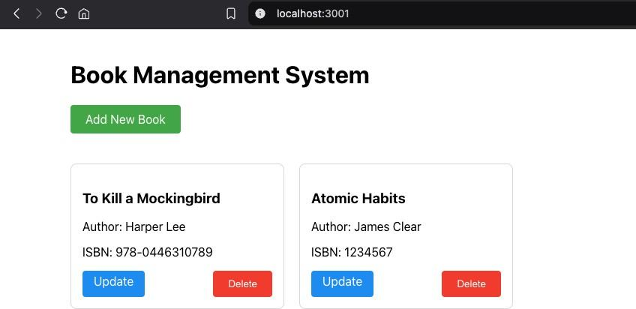

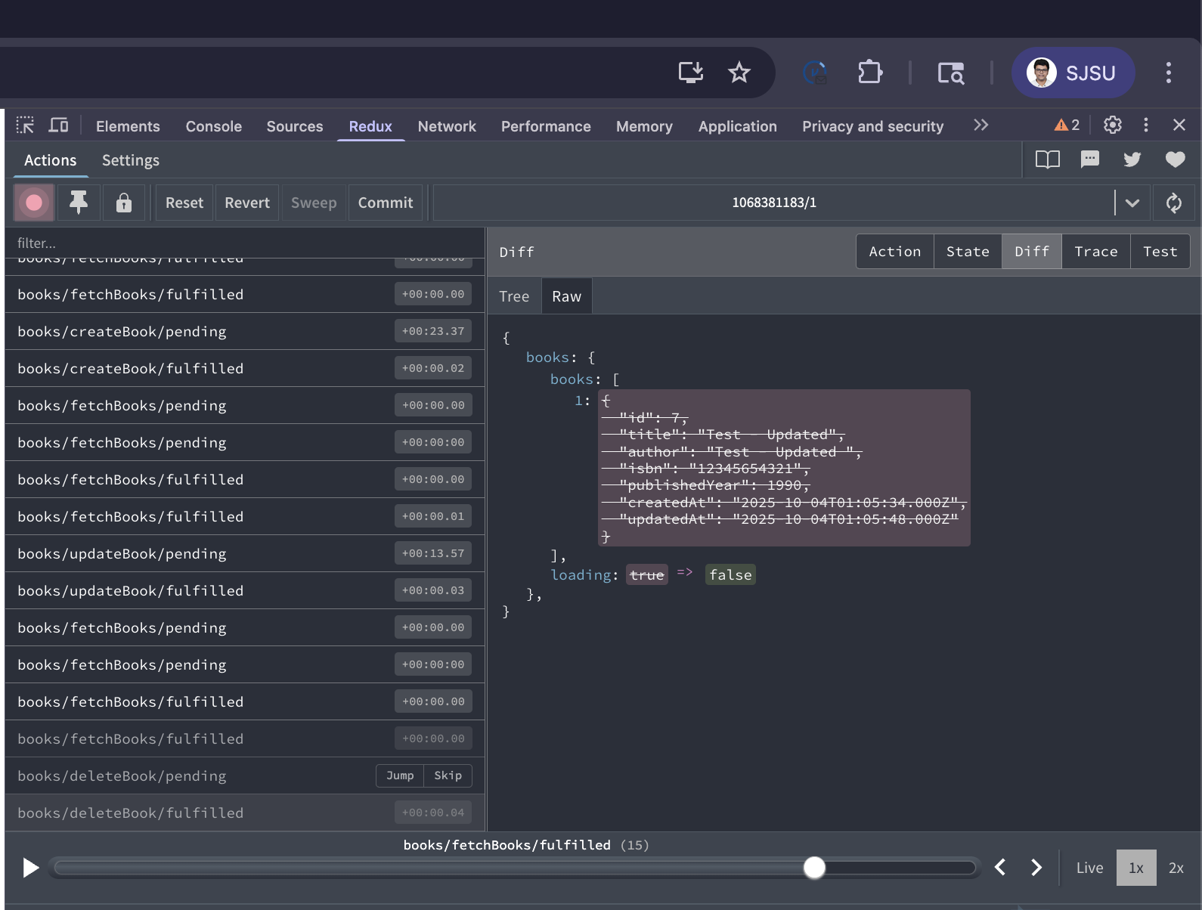

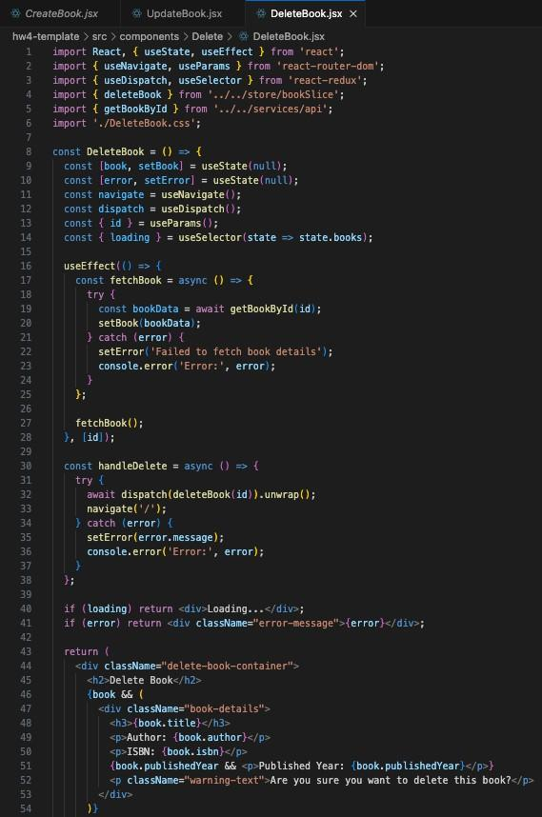

**PART -3**

**LLM Chat (Ollama + FastAPI + React)**

**API responses in Swagger/Postman:**

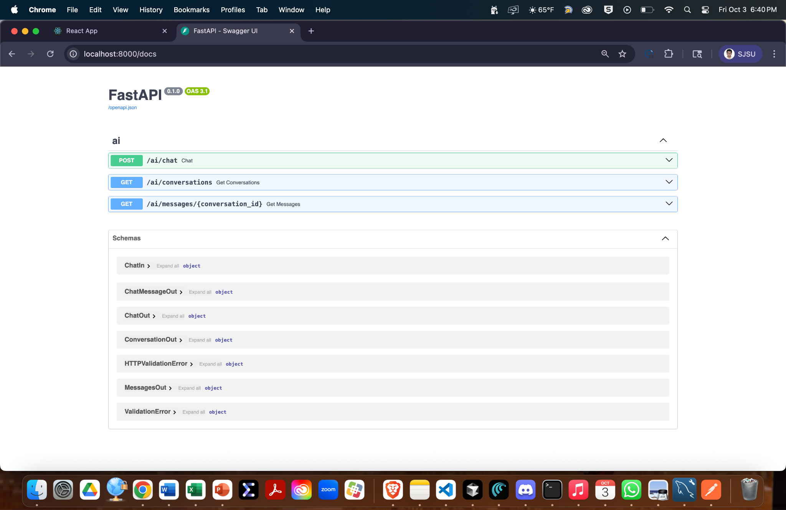

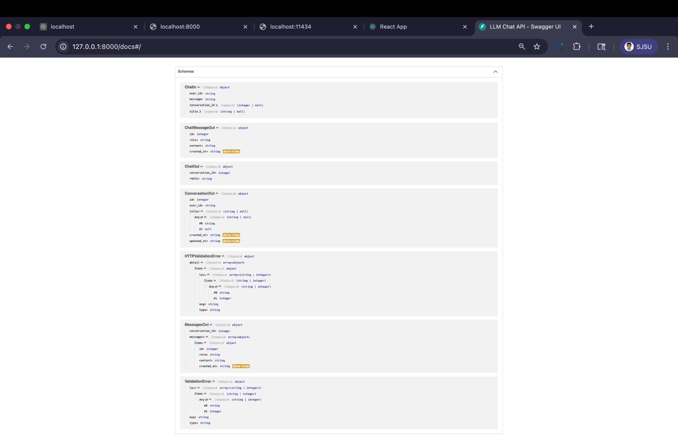

## 

## 

## 

## 

## 

## 

## 

## 

## 

## 1) POST /ai/chat — start a conversation

**Swagger**:

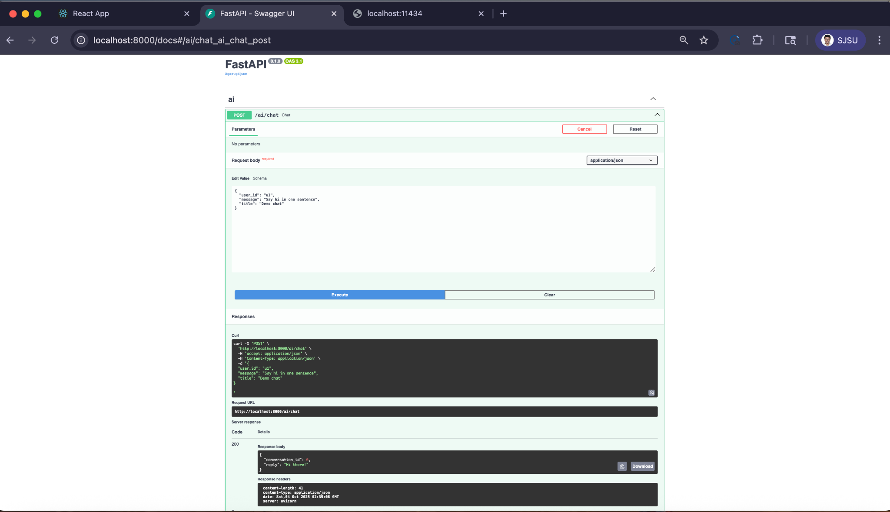

## 2) POST /ai/chat — continue the same conversation

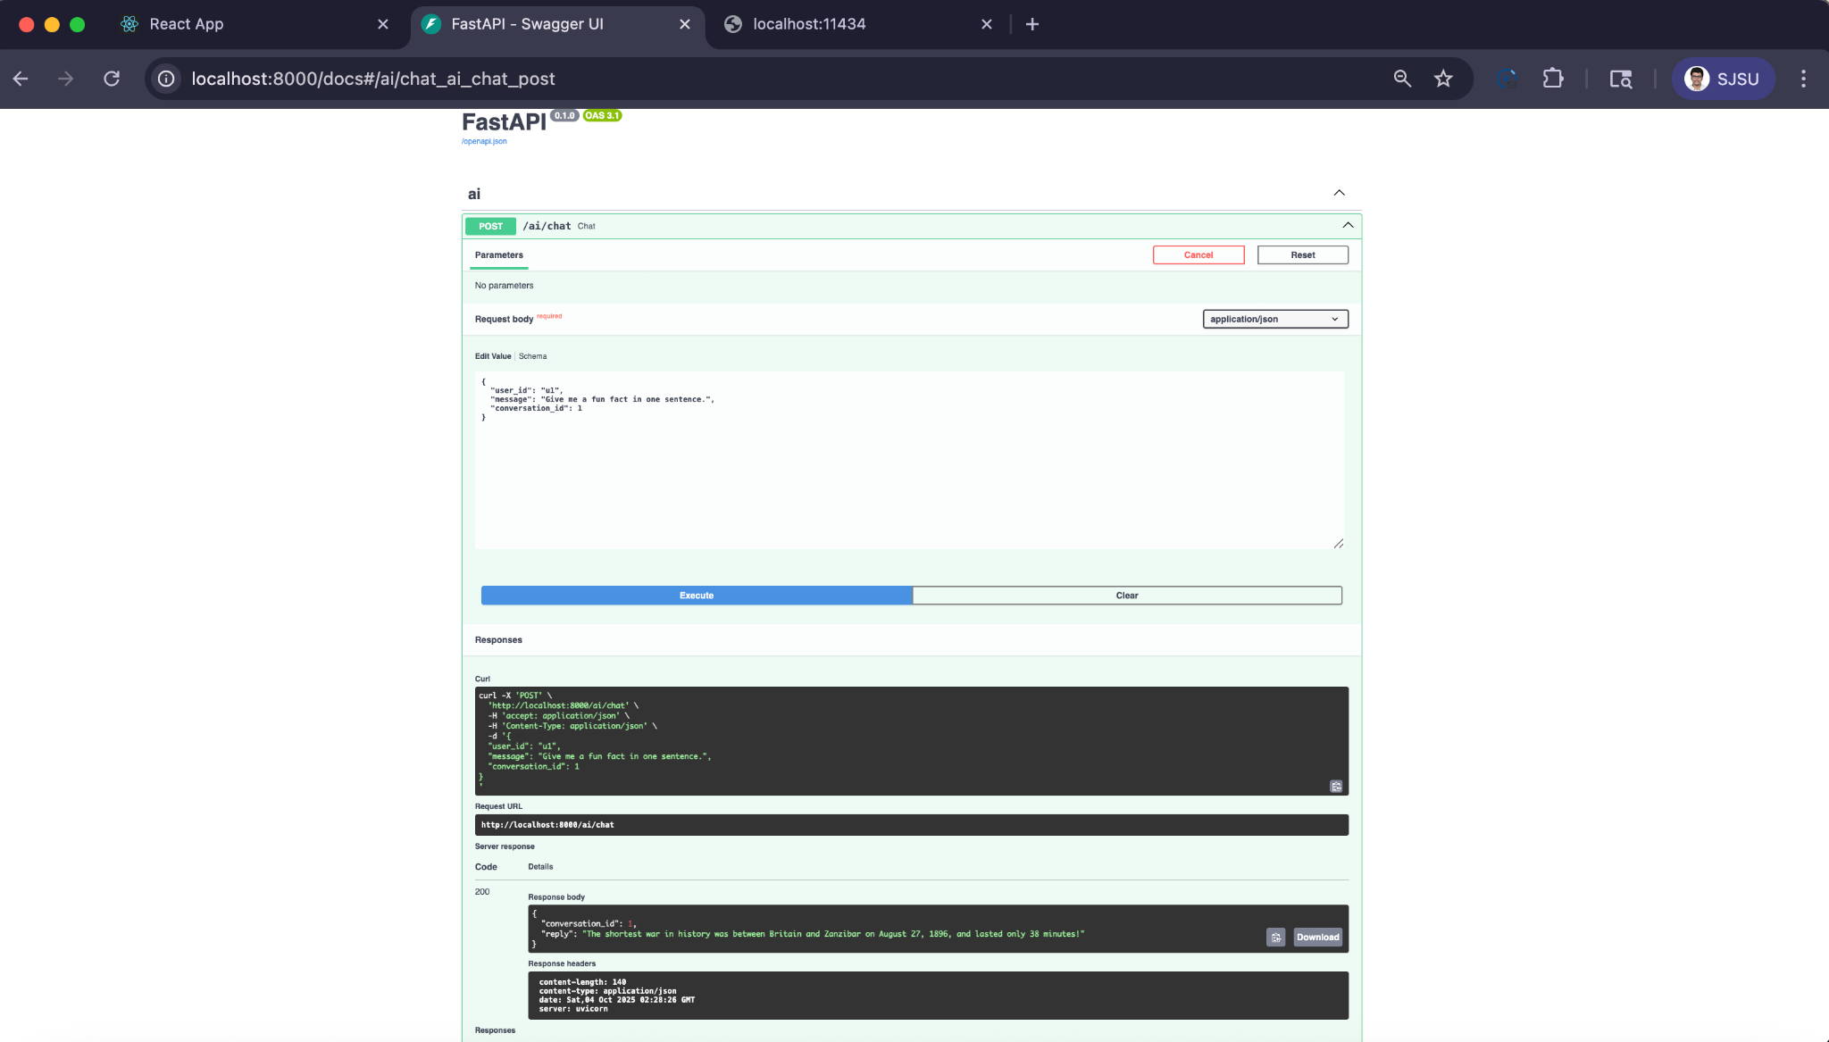

## 

## 

## 

## 

## 

## 

## 

## 

## 3) GET /ai/conversations — list the user’s chats

**Swagger**: set user_id = u1 in the query param

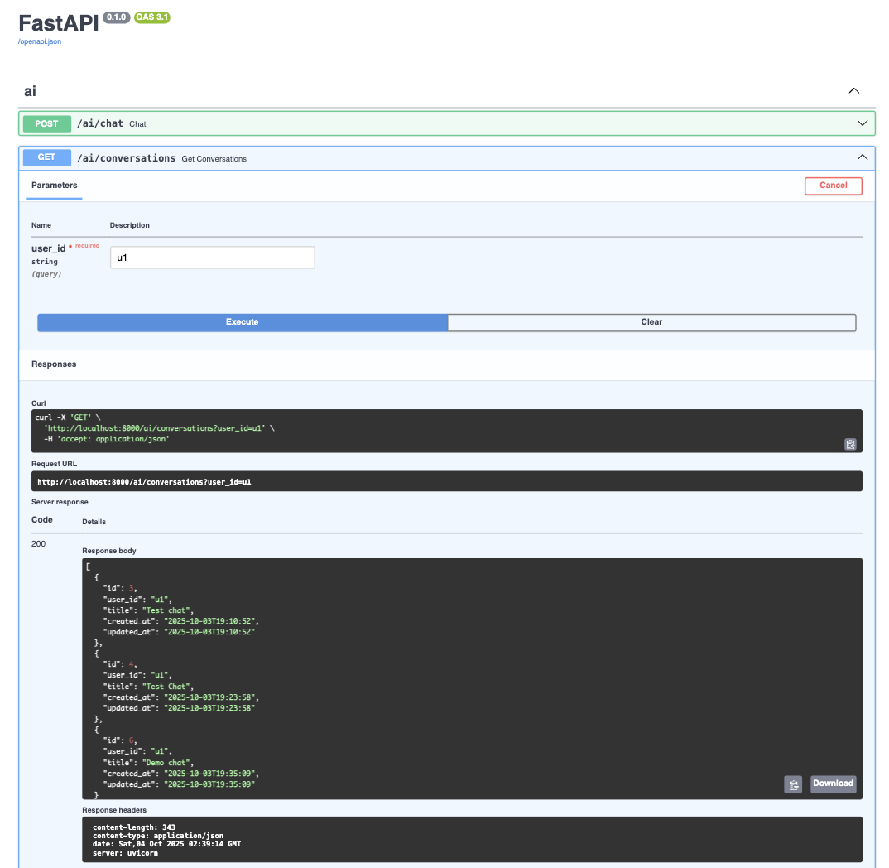

## **4) GET /ai/messages/{conversation_id} — all messages in a chat**

**Swagger**: path param conversation_id = 1

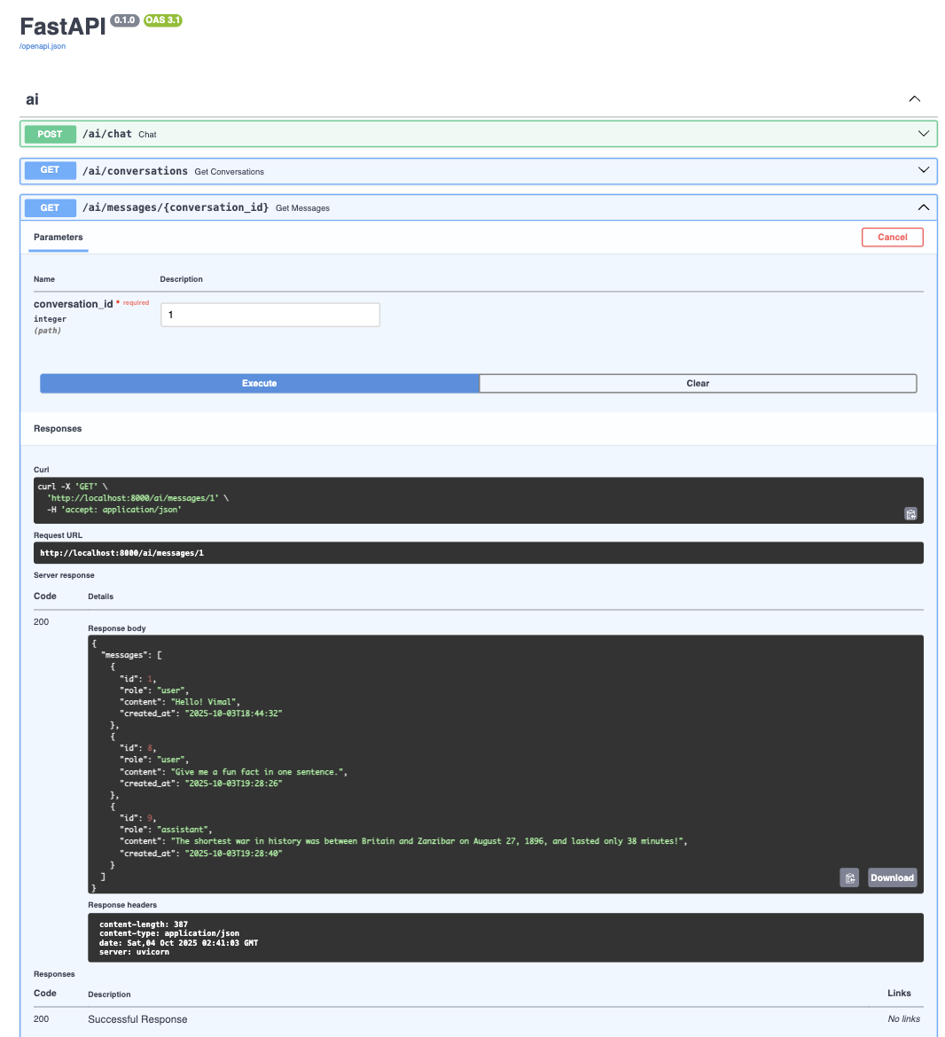

**DB Screenshots:**

**Conversations list**

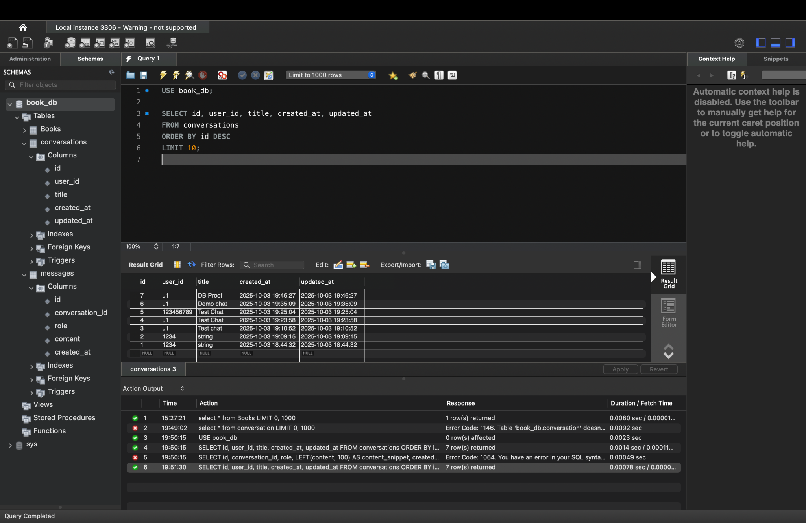

**Messages for one conversation :**

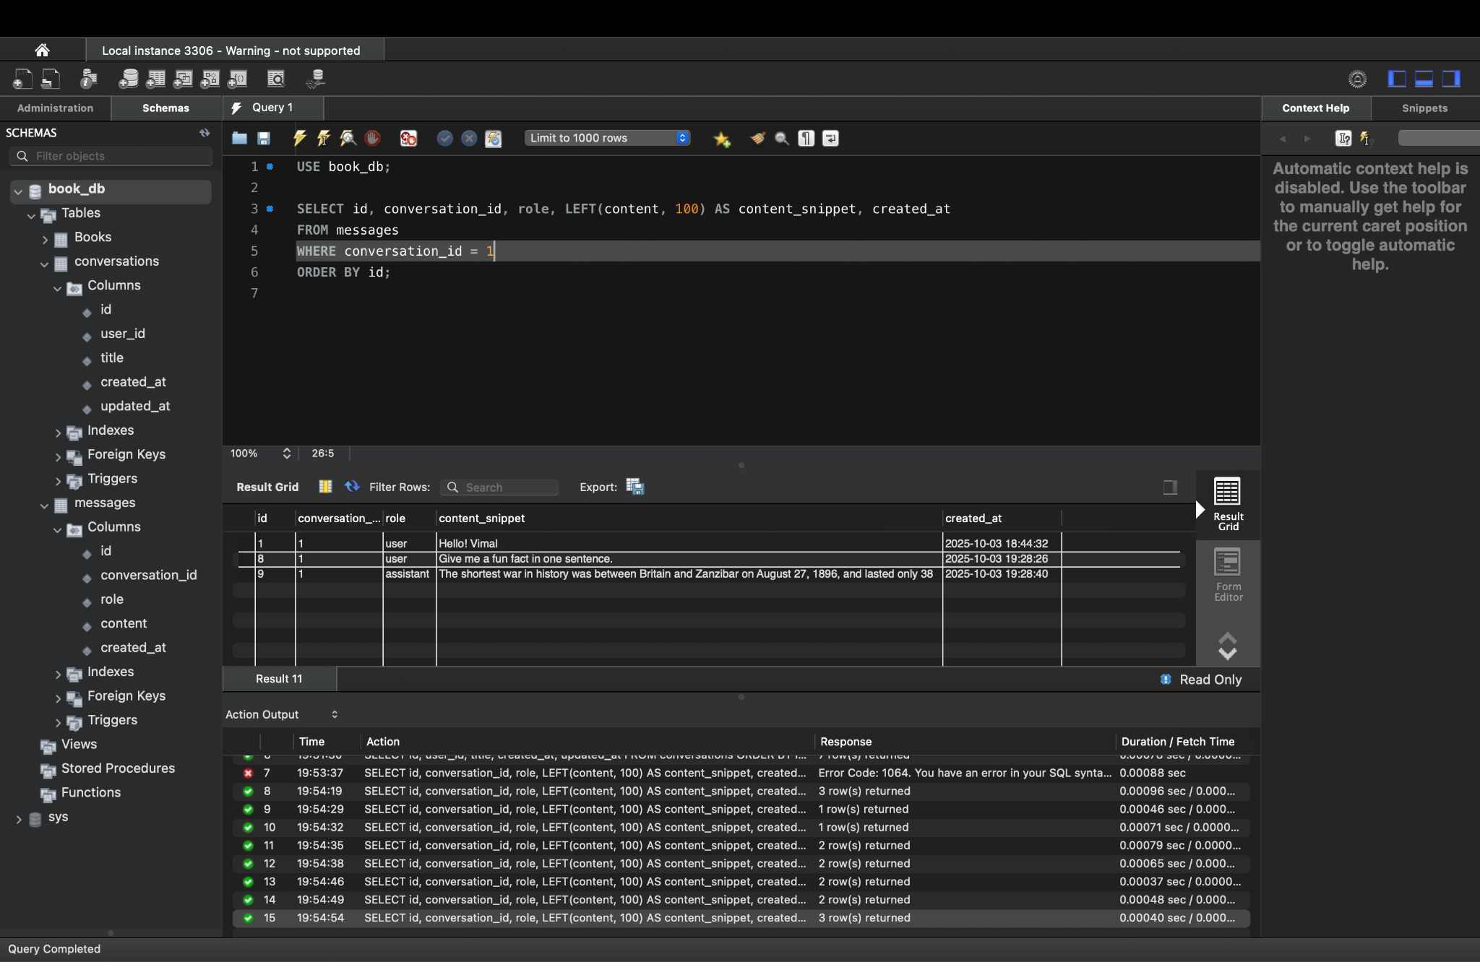

**Frontend — Redux Slice**

**○ fetchConversations, fetchMessages, sendMessage thunks using Axios.**

**Fetch Conversations:**

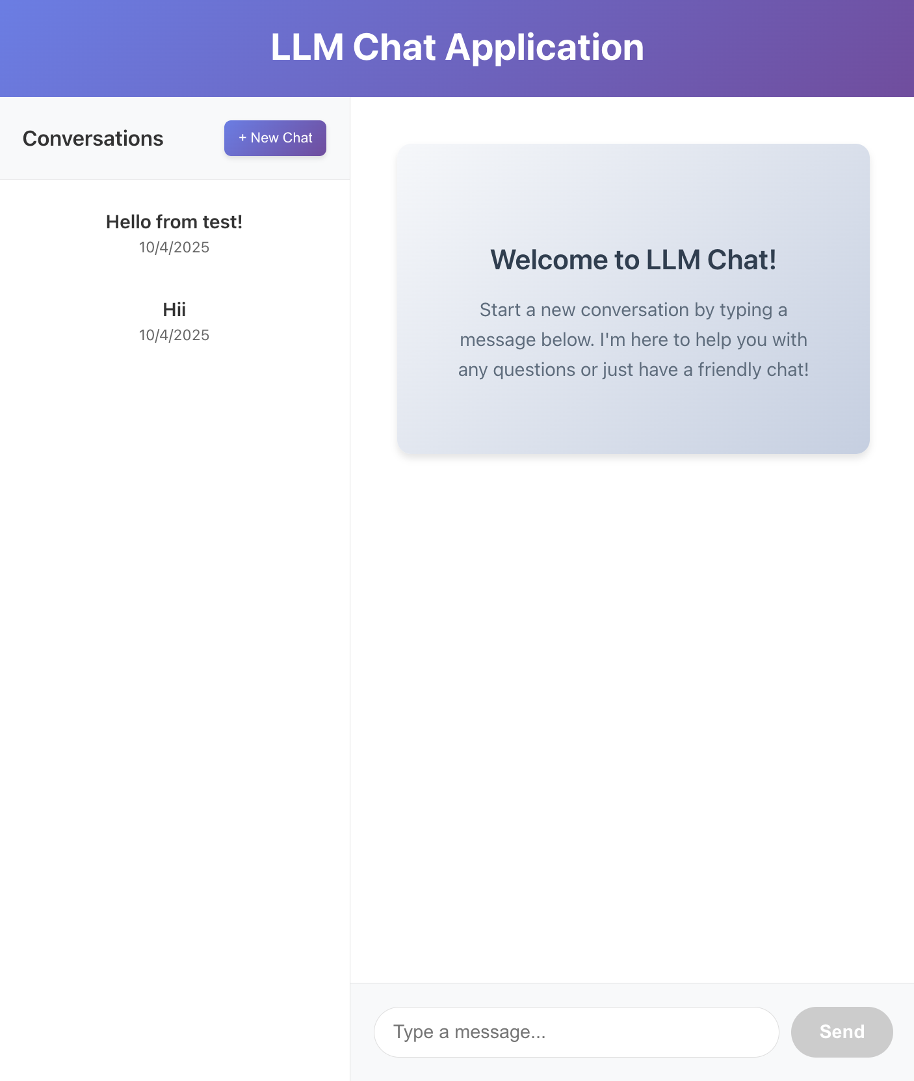

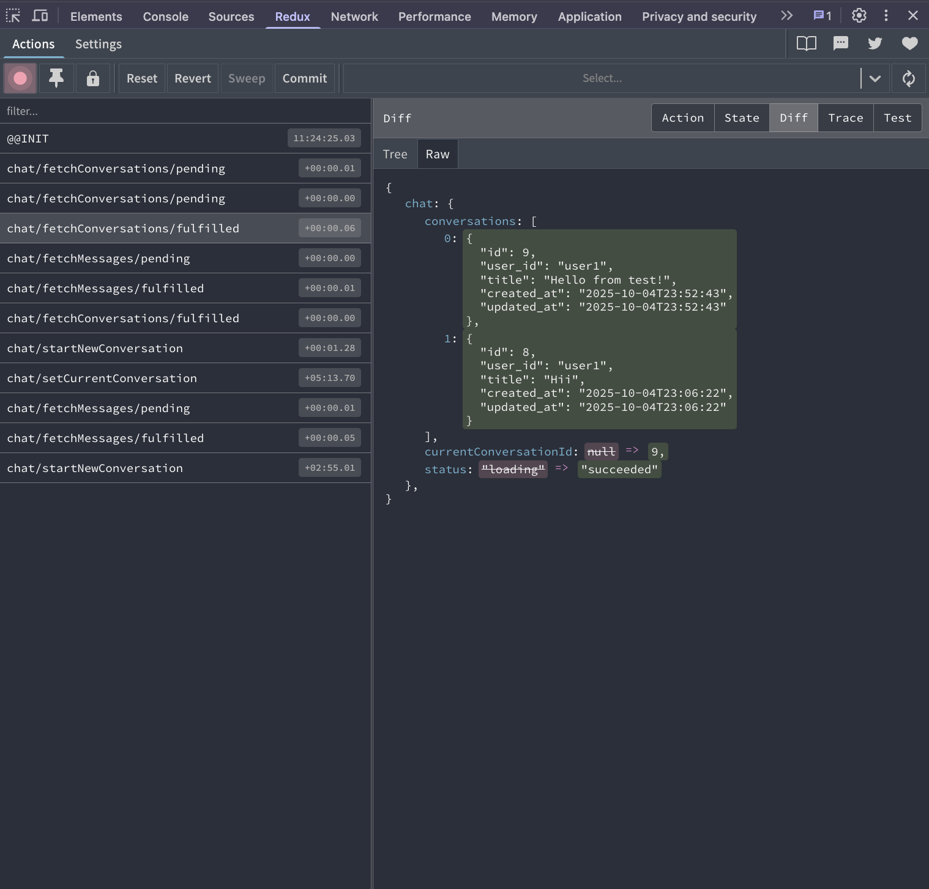

**Fetch Messages:**

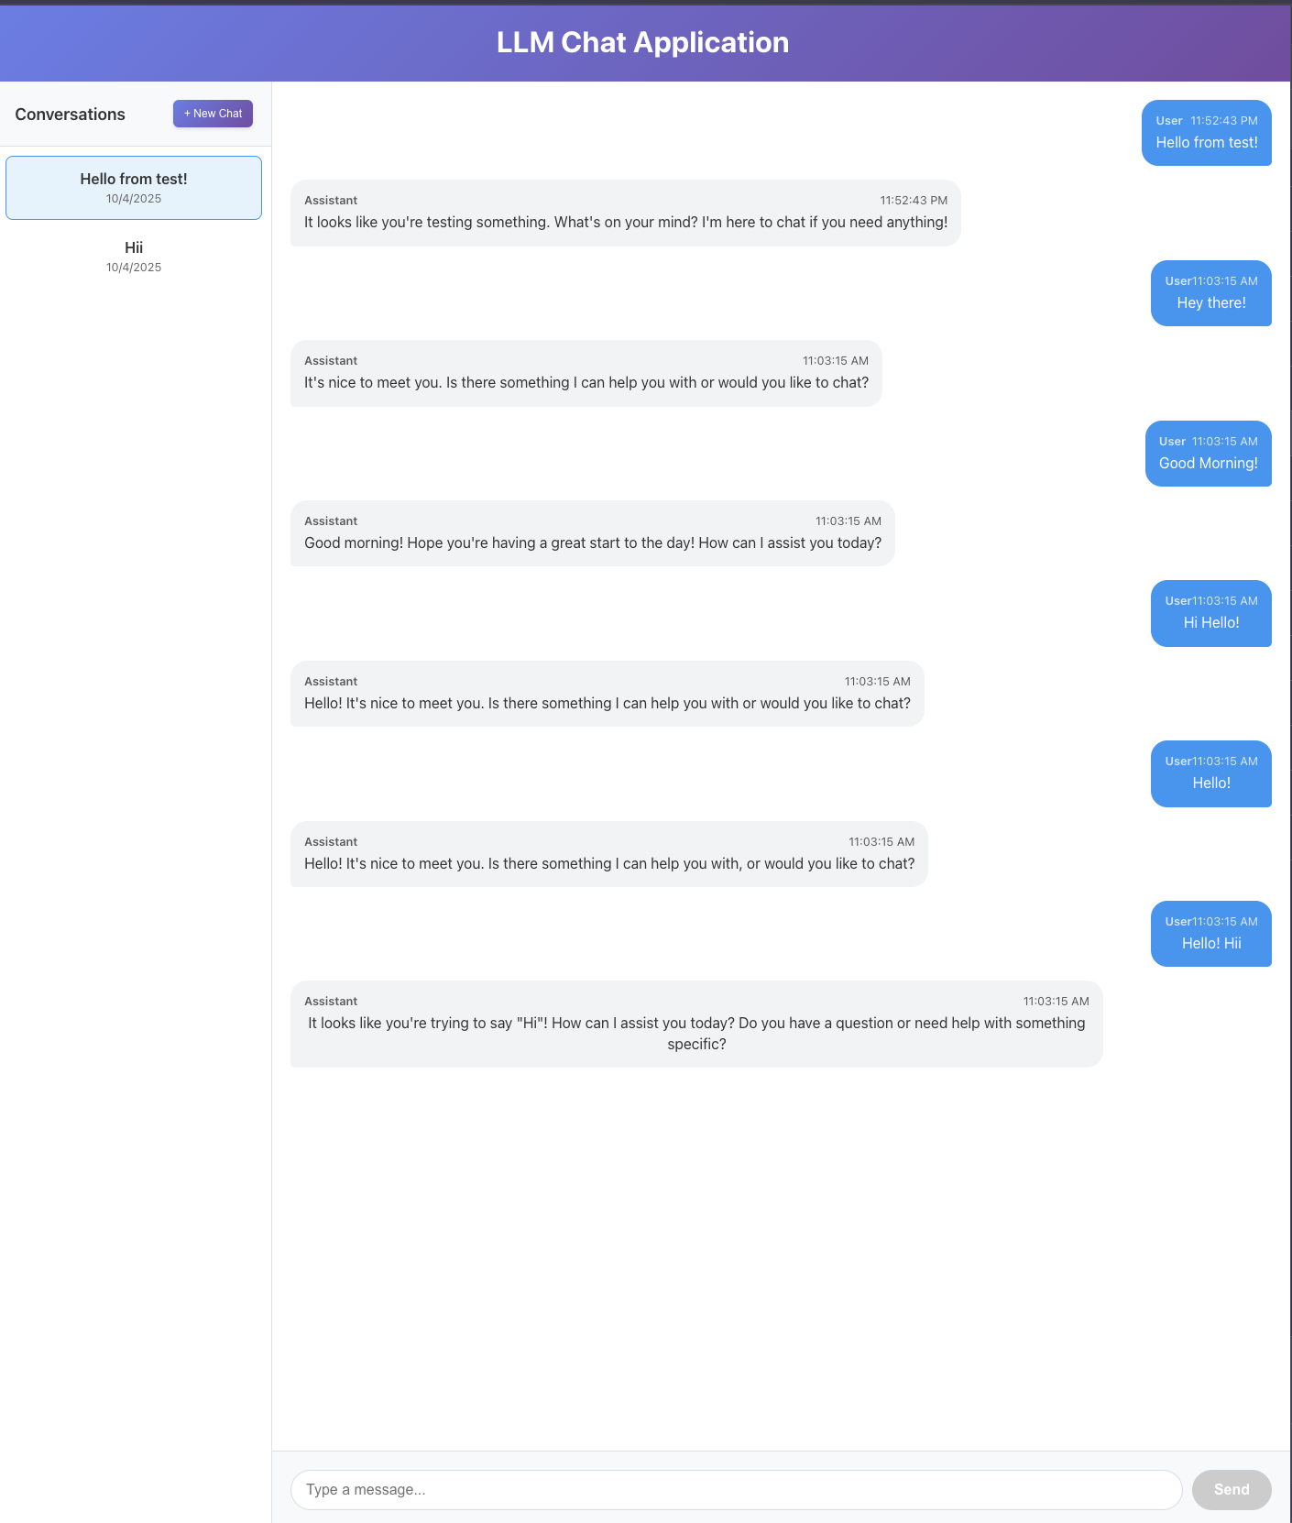

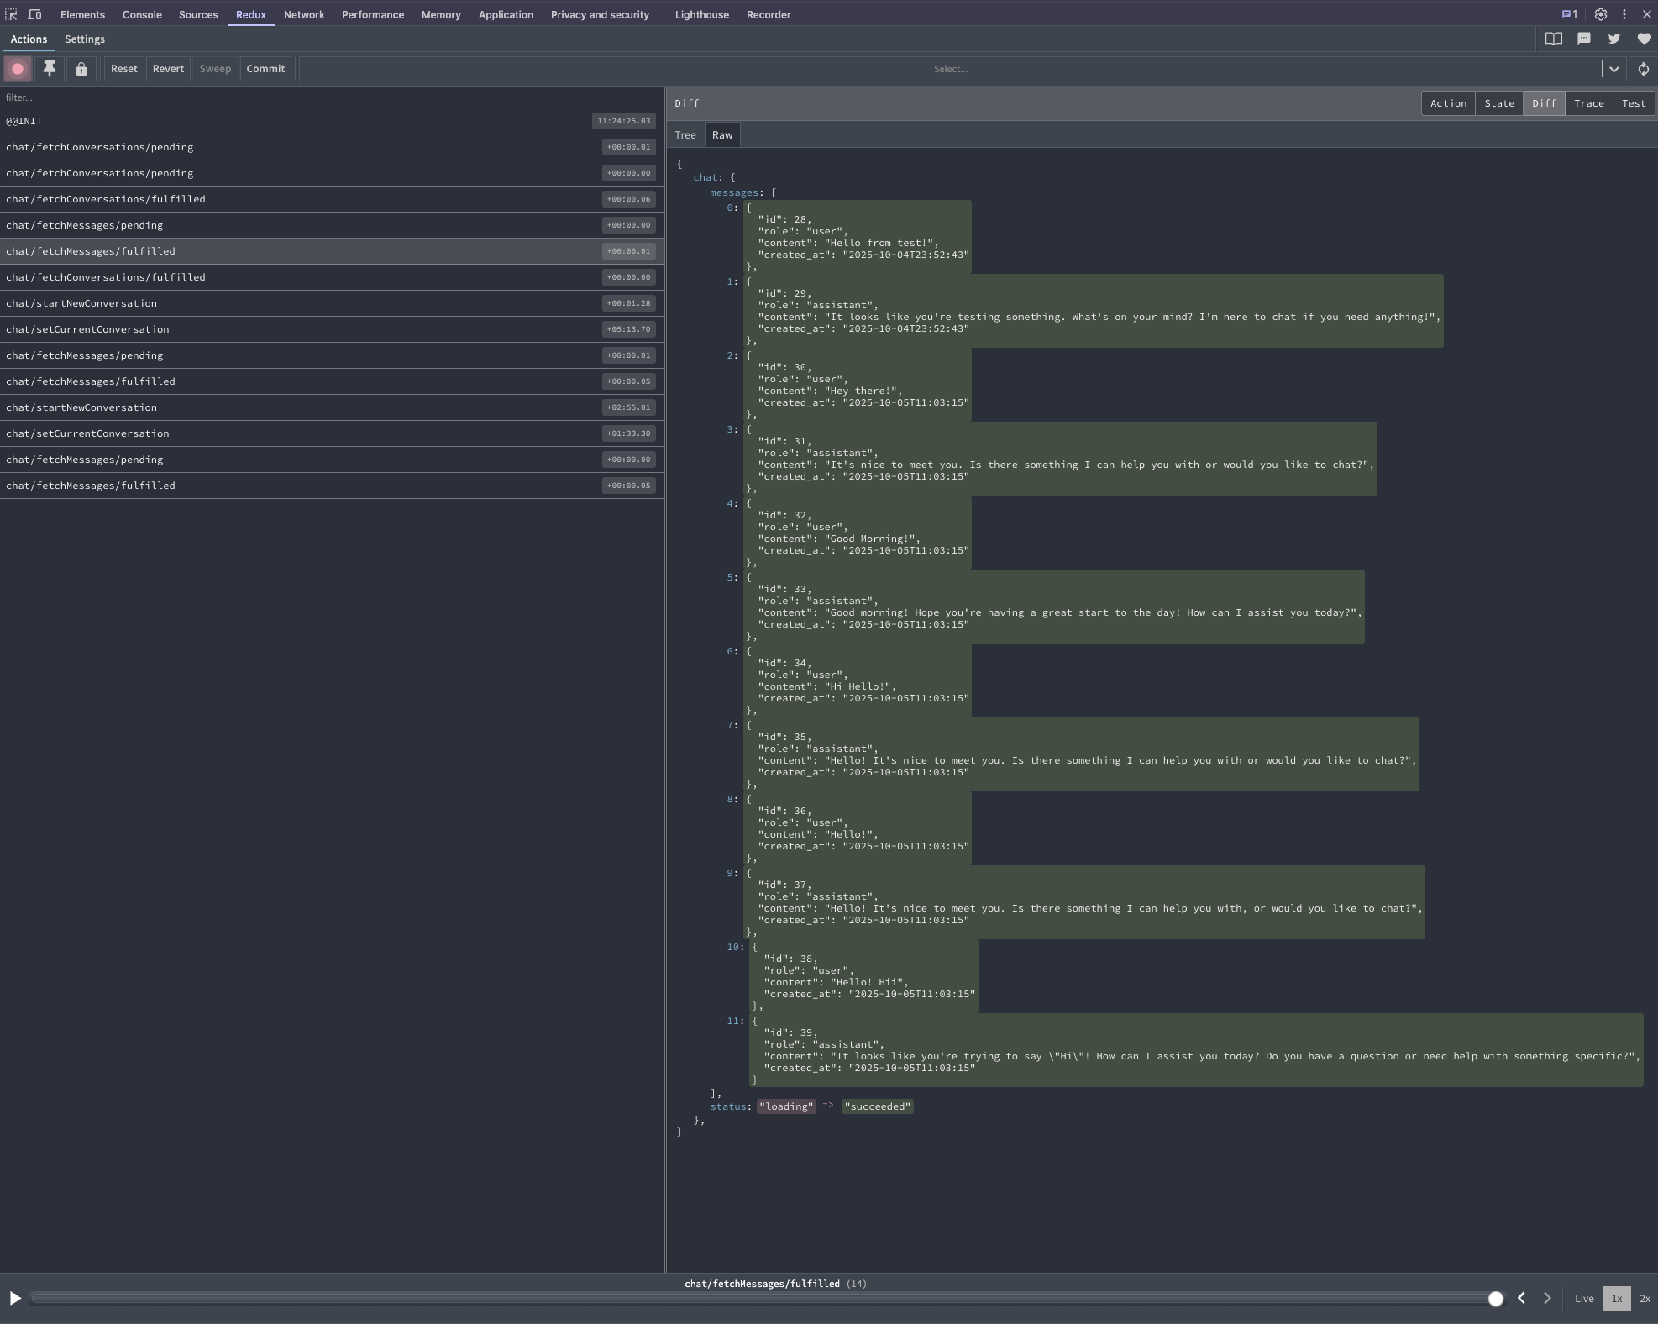

**sendMessage:**

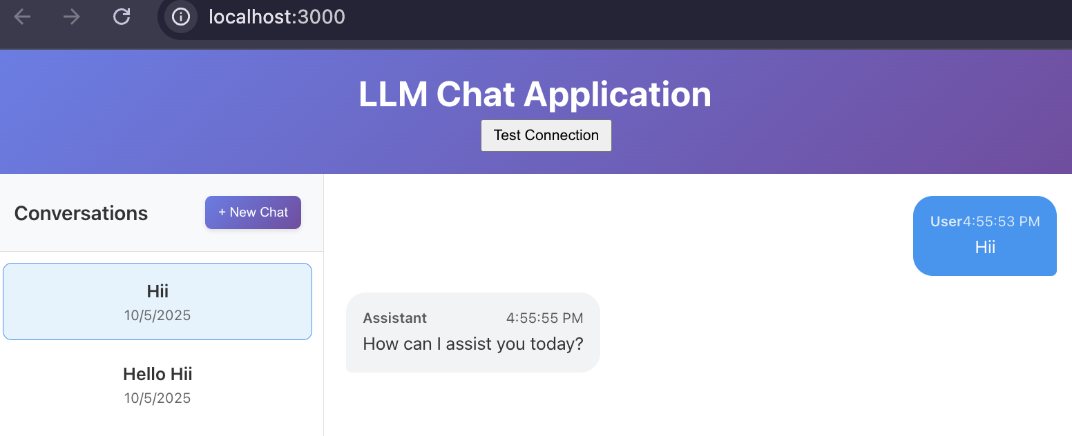

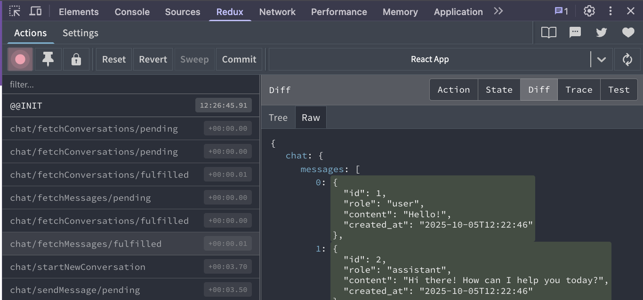

**LLM Chat UI:**

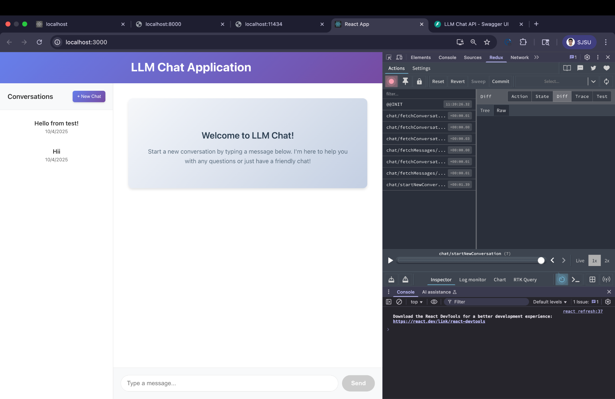

**Testing**

**cURL examples:**

**1)Start New Conversation:**

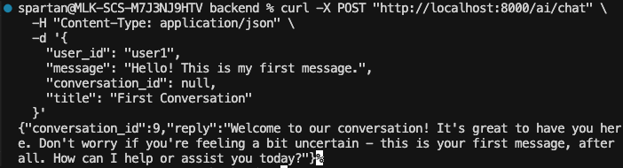

**2)Continue Existing Conversation:**

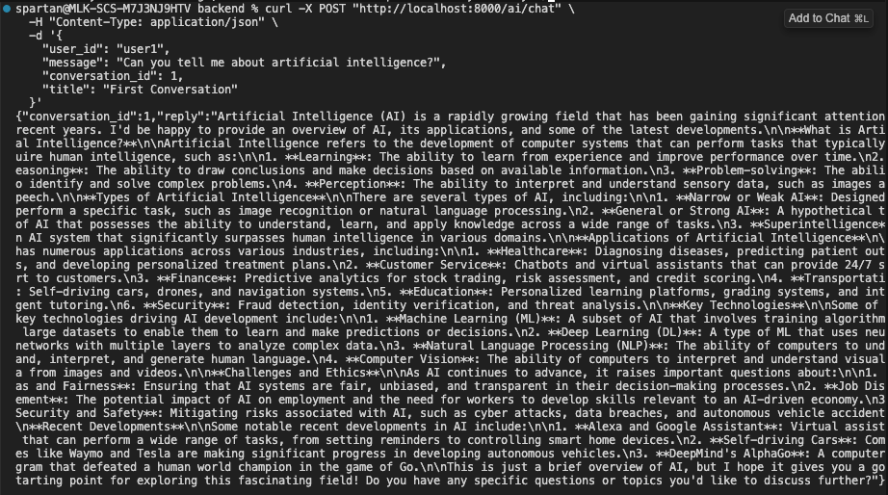

**3)List All Conversations:**

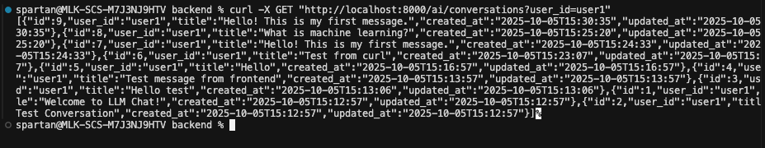

**4)fetch messages:**

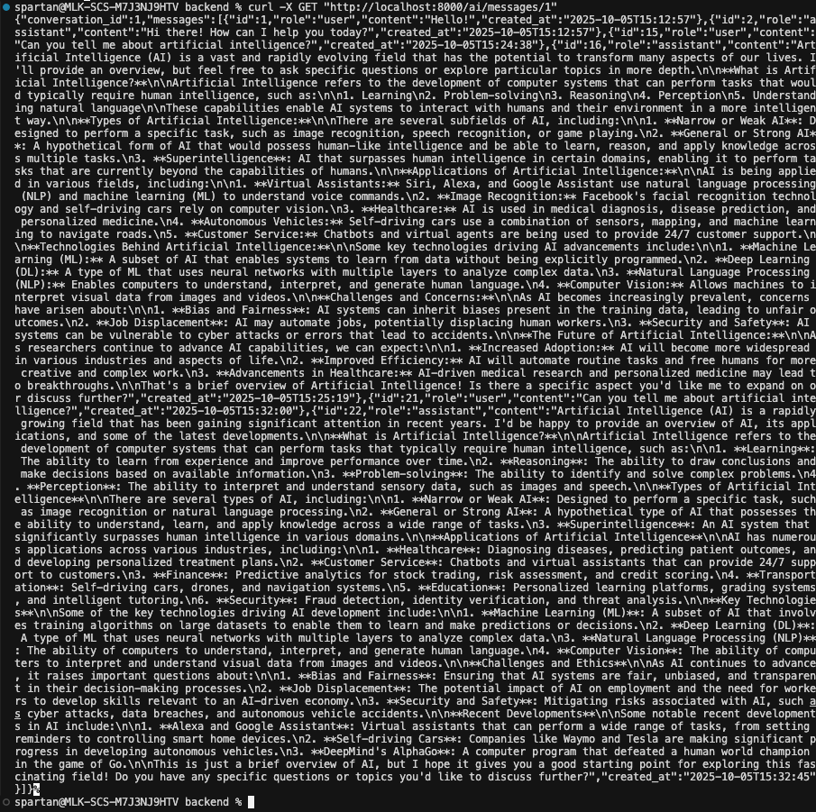

**CODE:**

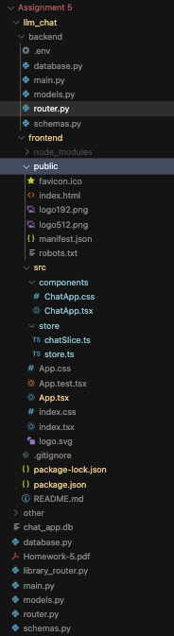

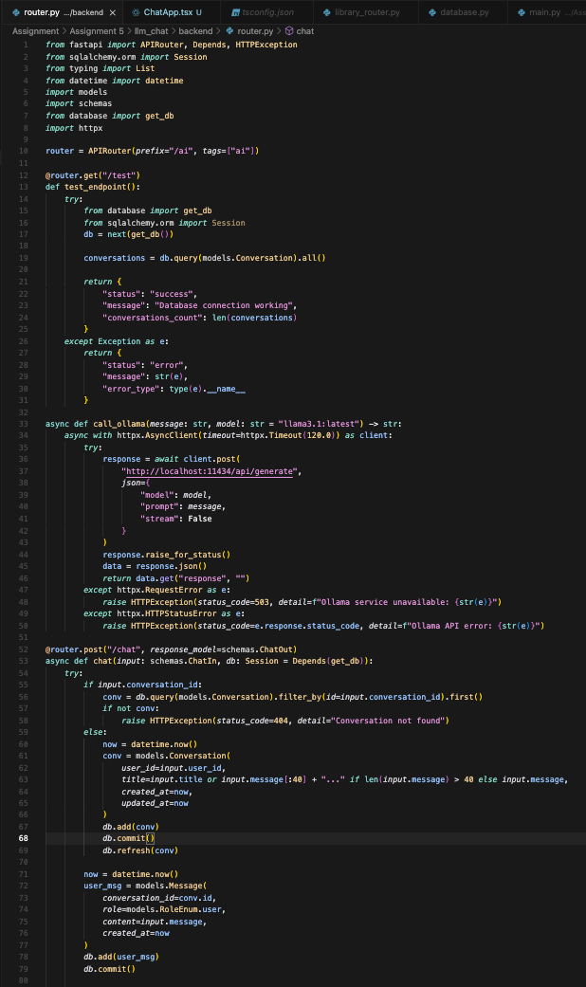

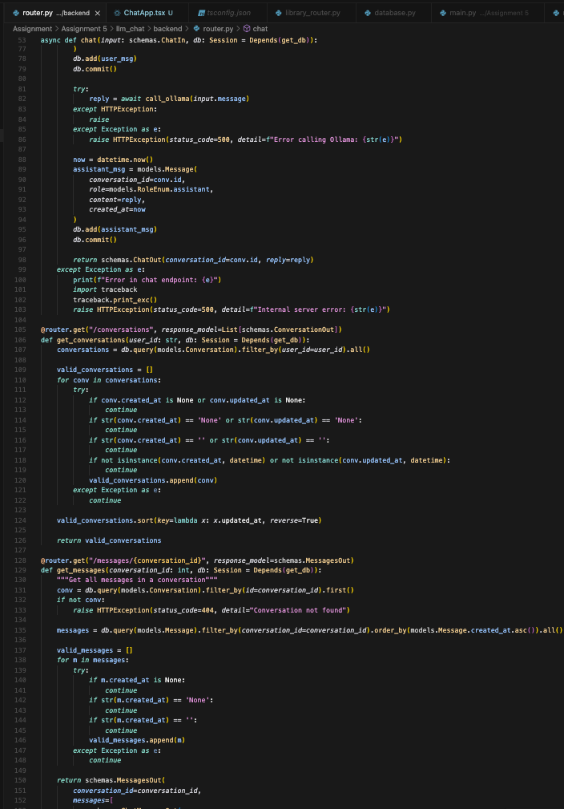

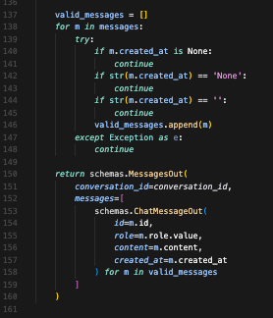

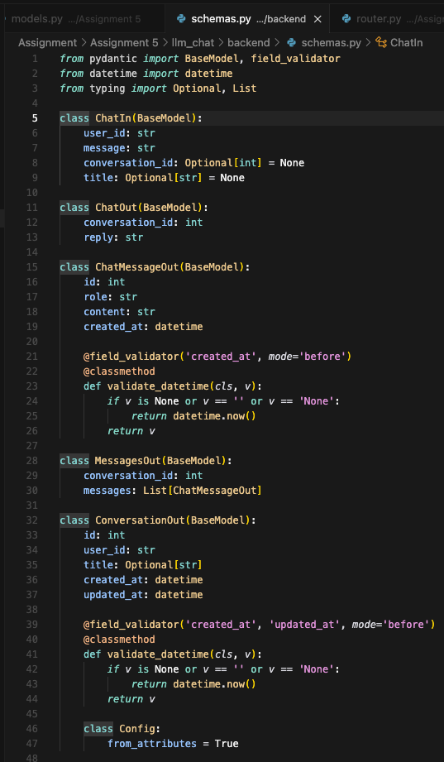

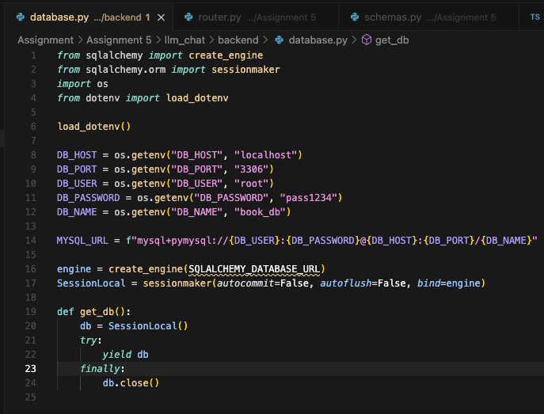

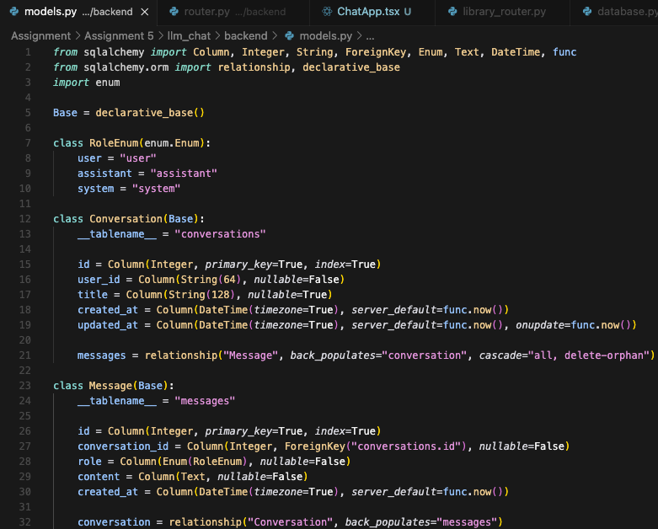

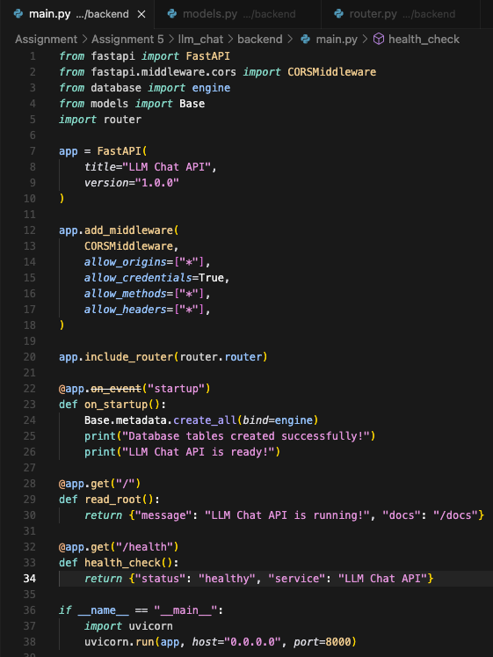

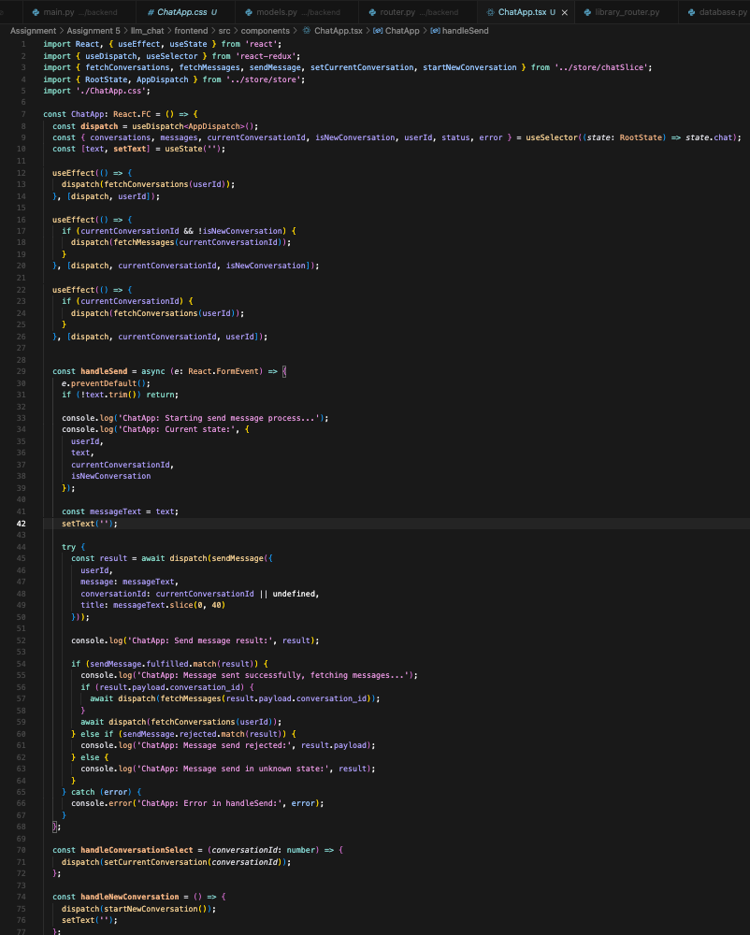

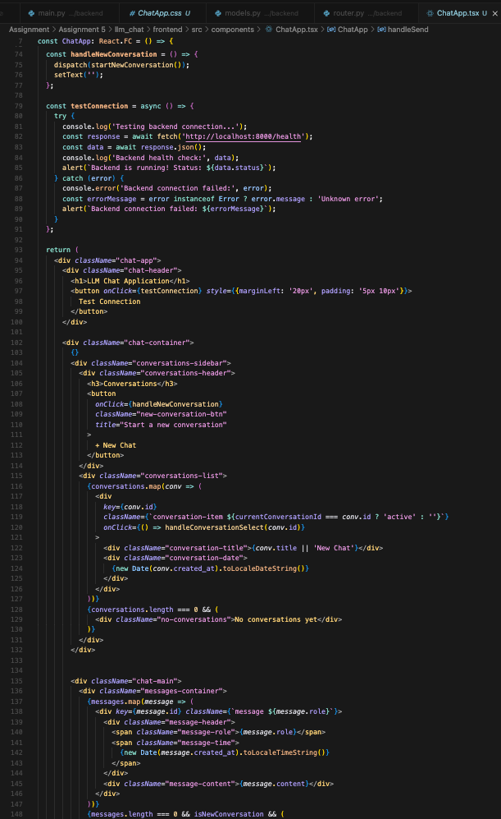

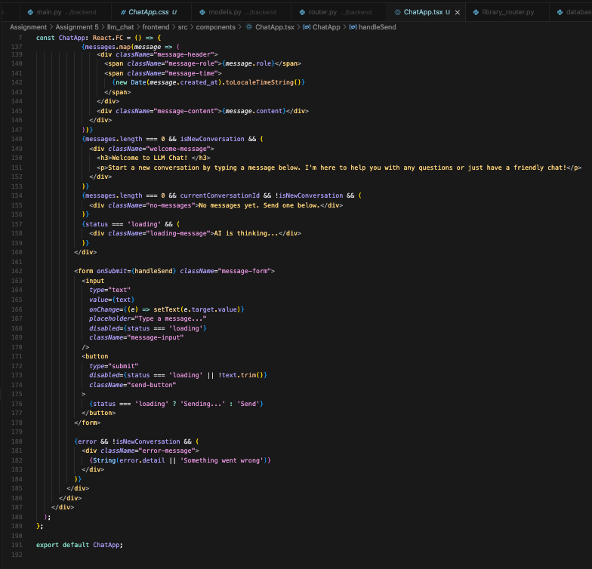

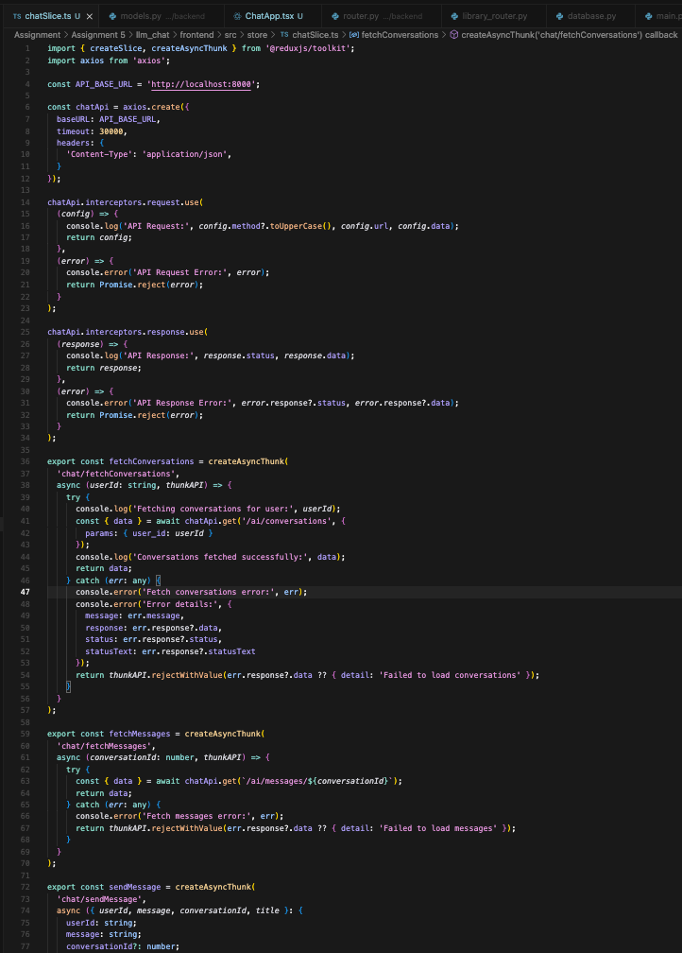

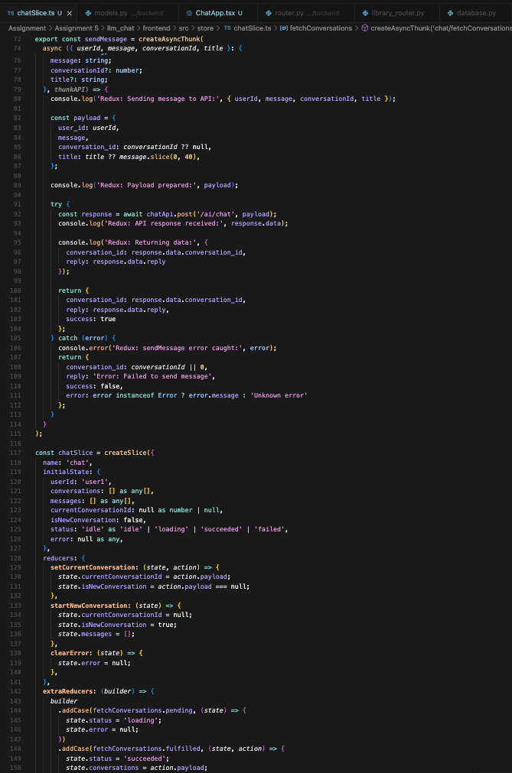

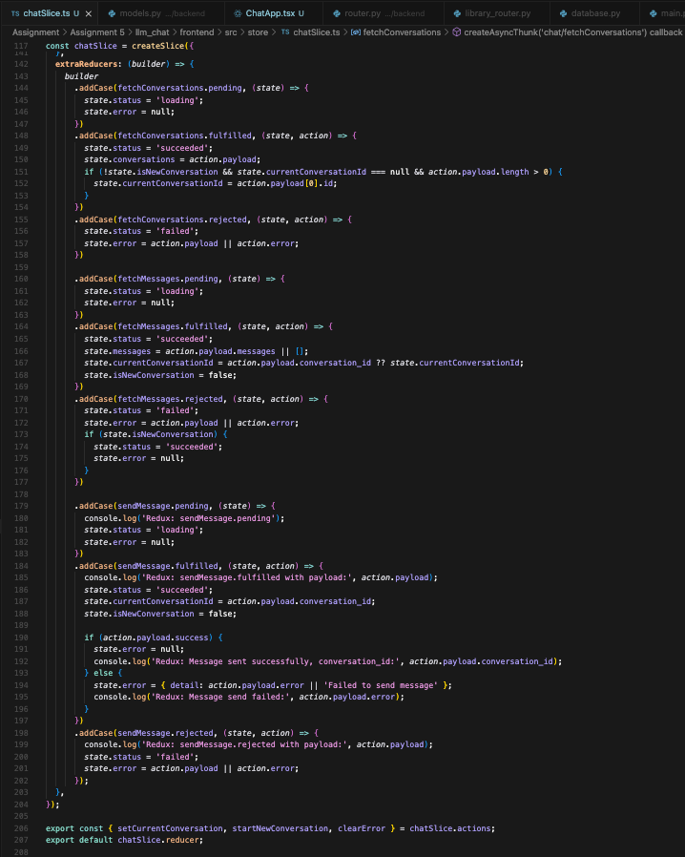

**WORKING CHAT:**

